# Level 1

## Supervisor Meeting

Spoke to martin about selecting the components for sensors and actuators. The choice of development board also came up.

The accelerometer that I choose should be based on the ability to continuously sample multiple sensors or with the ability to sample from each at a rate as fast as the limits based on the development boards sample speed.

Another consideration is the number of pins used by the sensor and on the board and the processing power of the board.

## Component selection

Arduino Mega is suitable, as is Arduino Due. Arduino Mega has more pins though.

Please see excel spreadsheet for further analysis.

## Communication using XBee modules

I downloaded XCTU and managed to discover the first XBee module in the software using the USB XBee dongle from sparkFun. It does not seem possible to connect to the other XBee module that is on the Arduino shield via the XCTU software directly. It may be necessary to program the XBee’s individually using the same dongle or to purchase another to allow easier testing. Since it takes 3 days to come and is £30 it seems better to try and program them individually.

Based on the work by Alexander Stassis and online tutorials (<https://learn.sparkfun.com/tutorials/exploring-xbees-and-xctu#configuring-networks)> it seems you configure the XBee module by selecting there:

* PAN ID which should be the same.
* Source Address which can be anything and is a personal address on the PAN.
* Destination Address which is broken into high and low



There are also different choices for the operating mode of the modules. At the top level this choice is between Transparent and API modes. API mode is a frame-based protocol suitable for larger more complicated networks while Transparent or AT operating mode simulates a serial line or wired connection. (<https://www.digi.com/resources/documentation/Digidocs/90001110-88/concepts/c_trans_api_modes_in_rf.htm)> - Digi explanation

(<http://cerescontrols.com/tutorials-3/xbee-basics-at/)> - AT mode tutorial

Since we are using a point to point network with two nodes the AT mode is most suitable with unicast transmission. This can be established by giving the 2 XBee modules each others address as destination address.



(<http://docs.digi.com/display/RFKitsCommon/XBee+transparent+mode)> - Digi user manual

PAN ID: 234

Co-ordinator (Family:XB24-B, Function Set: ZNet 2.5 Coordinator AT, Version: 1047):

* SH – 13A200
* SL – 4124256A

Router/End (Family:XB24-B, Function Set: ZNet 2.5 Router/End AT, Version: 1247):

* SH – 13A200
* SL – 40CC01AE

Hard to test without setting up the Arduino, so will try and write a simple program that sends data to the co-ordinator attached to the PC. Made sense for co-ordinator to be PC as it must always be on.

Found a tutorial program that tests connection by turning an LED on the board on:

(<https://www.arduino.cc/en/Guide/ArduinoWirelessShieldS2)>

The XCTU console is able to turn the LED on and off effectively. The next step then seems to be a program on the PC that can do this as well and receive data from the board and save it.

Another program sends counting from the Arduino to the PC using a python program. Python was chosen as the receiving language as it is easy to use the serial interface and quick to learn. This can be used to save the data for another program to analyse using a neural network.

(<http://www.toptechboy.com/arduino/python-with-arduino-lesson-2-installing-the-software/)>

This can send data to the python terminal successfully although formatting is off. Maybe due to the different versions of python.

## Reading Sensors Using ADC’s

### Single

Headers were soldered to all 5 of the sensors so they could easily be attached to the Arduino.

To start a single sensor was used to get the program running. A good tutorial for Arduino code is here:

(<https://www.arduino.cc/en/Tutorial/ADXL3xx)>

It uses the digital pins to provide the sensors 3.3V and GND connections. Aside from that it is quite simple, the sensor outputs are assigned to analog pins and then sent to the serial connection.

*Serial.print("1");*

*Serial.print(" ");*

*Serial.print(analogRead(sensor1x));*

*Serial.print(" ");*

*Serial.print(analogRead(sensor1y));*

*Serial.print(" ");*

*Serial.print(analogRead(sensor1z));*

*Serial.print(" ");*

*Serial.println();*

*delay(100);*

The first print sends a 1 to represent the sensor ID. Not necessary yet but may potentially be necessary later. The full code is called ADC_Serial_Single.

The python code was developed using a mixture of the python documentation and stack exchange questions as well as a course on udacity for python beginners. Some useful below:

<https://docs.python.org/3/library/io.html#module-io> - Opening files

<http://pythonhosted.org/pyserial/pyserial_api.html> - pySerial - library used

<https://anh.cs.luc.edu/python/hands-on/3.1/handsonHtml/io.html> - User input

<https://docs.python.org/3/library/csv.html#csv.list_dialects> - CSV read and write

It opens a serial connection with the XBee port and then checks if the input buffer is full. It then reads a line and receives and decodes the data.

It should receive: (ID XValue YValue ZValue \n)

It then splits this with the space as a delimiter into 5 and places the three values into 3 x,y,z lists. After a certain number of samples it asks the user whether it should continue or stop. Once it stops the data is saved to a CSV file found:

"/Users/Angelo555uk/Desktop/University/Year_4/Project/Results/sensorlog.csv"

This is written over each time currently.

This works for collecting sensor data from a single sensor and is called Serial_Test_Single.py.

### Multiple

The next step was to build on this and include more sensors, improving the Arduino and python code to handle this.

The initial version was created in the simplest manor possible. For the Arduino code this was fairly simple, the accelerometers outputs were connected to the MEGA in the next three analogue inputs and digital pins were created for the ground and power of each accelerometer. The Arduino code was initially written for three accelerometers as I did not have sufficient wires to connect 5. A loop was then added to the single version that cycles through the sensors after each sample:

for(int i=0; i<NO_OF_SENSORS; i++){

Serial.print(i+1);

Serial.print(" ");

Serial.print(analogRead(sensorInfo[i][0]));

Serial.print(" ");

Serial.print(analogRead(sensorInfo[i][1]));

Serial.print(" ");

Serial.print(analogRead(sensorInfo[i][2]));

Serial.print(" ");

Serial.println();

delay(20);

}

An array of the pin names was used to parameterize the analogRead() function call. At this point the MEGA continues sending readings with the ID of the sensor attached indefinitely. This program is called ADC_Serial_Multi.

Serial_Test_Multi.py was then developed to go with this code. It is basically an extension of the single version and uses 15 arrays to collect the x,y and z readings for each sensor using the ID as an indicator of which array to save the values to:

sensorID = readings[0]

        if sensorID == '1':

            x_values1.append(readings[1])

            y_values1.append(readings[2])

            z_values1.append(readings[3])

        elif sensorID == '2':

            x_values2.append(readings[1])

            y_values2.append(readings[2])

            z_values2.append(readings[3])

        elif sensorID == '3':

            x_values3.append(readings[1])

            y_values3.append(readings[2])

            z_values3.append(readings[3])

        elif sensorID == '4':

            x_values4.append(readings[1])

            y_values4.append(readings[2])

            z_values4.append(readings[3])

        elif sensorID == '5':

            x_values5.append(readings[1])

            y_values5.append(readings[2])

            z_values5.append(readings[3])

Once the user chooses to finish it places the readings into 1 of 5 csv files for each sensor and saves them as follows:

timestamp = datetime.datetime.utcnow()

path1 = '/Users/Angelo555uk/Desktop/University/Year_4/Project/Results/Sensor1log-{:%d%b,%H.%M}.csv'.format(timestamp)

This uses the datetime library to add a timestamp to each path making the filename unique so it does not overwrite the data each time. This was tested and works using three sensors.

### Multiple Alt

As the simplest implementation, it was clear that this code could be improved substantially. It also became clear that a better method of version control was probably required. For now though the code was developed with the tag Alt.

The following goals were made for the Arduino code:

* The Arduino should only sample when the python is receiving the data to reduce power consumption

To achieve this two-way communication between the python and Arduino code was required. This is fairly simple using the loop:

if (Serial.available() > 0){

serialRX = Serial.read();

Which checks if the serial input buffer has anything in it and then reads it out. Using this in the loop:

while(!start){

if (Serial.available() > 0){

serialRX = Serial.read();

if (serialRX == 'S'){

start = true;

}

}

}

The Arduino now waits for the python to send an S character before moving to the sampling loop which is in a while(start) loop. At the end of the sampling loop the Arduino then checks again if serial is available. If not it samples the next accelerometer. If a second S is received from the python however start is set to false and the Arduino leaves the sampling loop and waits in the start loop for another S. This means the Arduino only samples when the python script is saving the data.

The goals for the python scripy:

* Send an S to make the Arduino start sampling and an S to stop sampling once data has been collected.
* Produce more efficient/elegant code than the 15 arrays approach.
* If possible find a better way of formatting and manipulating data using python.

I did a tutorial on numpy which seems to be a good way to manipulate the data and format it easily:

<https://campus.datacamp.com/courses/intro-to-python-for-data-science/chapter-4-numpy?ex=5>

First though the run loop was preceded by the need for a user input before continuing. Once the user presses a key an S character is sent to the Arduino which tells it to start. Once the user chooses to finish collecting samples a second S is sent before closing the serial port so that the Arduino stops sampling.

There was originally a problem using this, the Arduino was not recognising the character. This was fixed by sending a data of type byte:

arduinoSerial.write(b'S')

The Arduino now only samples while this program collects data.

Importing Numpy allows both the second and third goals to be met. The serial data is still split into ID,X,Y,Z,/r/n but now the first four items are placed into a single list.

There was an issue here with data being received in strange ways. E.g.



This showed the need for finding the cause and also data verification to prevent errors. Testing showed that the Arduino delay between sensor sampling affected the amount of packet loss.

Data verification was introduced that only saved received data that was of length 5 and contained no empty objects. When a packet was received that did not meet this requirement it was discarded and a counter was incremented. This meant the number of lost samples could be printed to the console for testing:

if (len(data_readings) == 5 and '' not in data_readings):

            int_data_readings = list(map(int,data_readings[:4]))

            data_log.append(int_data_readings)

        else:

            badSamples += 1

Note also the map function used to save the ID,X,Y,Z values as type int, this was required as some of the values were being saved as strings and when converting the list to a numpy array, the array will take on 1 unified type. This needed to be an Int for data manipulation.

Using the lost sample counter different delays were tested with 1000 samples.

|  |  |  |  |  |  |
| --- | --- | --- | --- | --- | --- |
| Delay (ms) | Run 1 Lost Packets/1000 | Run 2 Lost Packets/1000 | Run 3 Lost Packets/1000 | Run 4 Lost Packets/1000 | Avg Lost Sample rate |
| 10 | 134 | 143 | 149 | 146 | 14.3% |
| 15 | 137 | 132 | 138 | 131 | 13.45% |
| 20 | 3 | 0 | 0 | 0 | 0.075% |

A delay of 20ms therefore will be used. Less time than this probably means the data is being transmitted too fast. This is sufficient for a stationary Arduino and so may change with practical use.

It takes about 100 microseconds (<https://www.arduino.cc/reference/en/language/functions/analog-io/analogread/)> to read an ADC so with the 3 that is 20.3ms per sample cycle. And with 5 sensors that is 101.5ms sampling rate for each sensor or about 10 samples per second. This seems like it should be sufficient speed not to miss events while remaining slow enough for the python to keep up.

Once the samples had all been put into the data_log list and sampling had finished, data_log is duplicated as a numpy array, np_data_log. Numpy arrays allow far more options when manipulating data. The following line for instance can be used to select the X,Y and Z values for all rows that have the int i as ID.

np_temp = np_data_log[:,[1,2,3]][np_data_log[:,0] == i ]

Originally this was used to place the data from each sensor into separate arrays so that it could then be concatenated and saved in a single CSV file. This produced a number of formatting errors. If a packet was lost the amount of samples from each sensor was different meaning they could not be concatenated into one array.

This was fixed:

np_data_log = np.array(data_log)

for i in range(1,NO_SENSORS+1):

    length.append((np_data_log == i).sum())

np_difference = max(length) - np.array(length)

for i in range(0,NO_SENSORS):

    if (np_difference[i] != 0):

        for j in range(0,np_difference[i]):

            np_data_log = np.concatenate((np_data_log,[[i+1,0,0,0]]), axis=0)

np_data_sorted = np_data_log[:,[1,2,3]][np_data_log[:,0] == 1 ]

for i in range(2,NO_SENSORS+1):

    np_temp = np_data_log[:,[1,2,3]][np_data_log[:,0] == i ]

    np_data_sorted = np.concatenate((np_data_sorted,np_temp), axis=1)

The code first creates a length list that holds the number of samples from each sensor. This is used to find the sensor with the most values and then to create an array that holds the number of samples that each sensor has less than the sensor with the most samples.

If a sensor has less samples it is then padded with X,Y,Z values equal to 0,0,0 so that each sensor has the same number of samples. It is then concatenated before being written with one line to a CSV file shown below.



Testing shows that this seems to work quite well and should be possible to expand easily to 5 sensors. The python script is parameterizable so that the number of sensors and samples can be changed with a constant.

A try exception was also added to opening the serial port.

## Further Goals

* Try 5 sensors and update the Arduino code for this.
* Git for version control and naming scheme?
* Calibration of sensors.
* Attach instrumentation to car.
* Breaking python script into function blocks.
* Averaging from sensors?
* Ability to easily select the format of the saved data (Depends on whether data management is done in python or required as csv. Can python do graphs?)

## Version Control

Git was introduced as a method of automatic version control and rather than creating copies of files this can now be used to make changes to certain files that are currently in use. As such the filenames were altered. Serial_Test_Multi.py is now Serial_Test_MultiV1.py and Serial_Test_MultiAlt.py is now Serial_Test_MultiV2.py and the Arduino files are named similarly. Eventually this should be moved from serial test to working program although maybe once calibration and 5 sensors are tested properly.

## 5 Sensor Test

Now I have the extra wires the Arduino code was updated to include the extra pin definitions for 5 sensors and they were connected to the Arduino as per the other accelerometers. The python code was already setup for 5 sensors.

It worked well:



Seems to be a change in some values maybe due to a voltage drop due to 5 sensors. This should be checked at some point. Potentially before the calibration is performed although the car battery may also drive the board differently and the voltage of the board and ADC reference will all affect the calibration stage.

Changes were committed to the main branch as 5 sensors are standard.

## Further Goals

* Voltage drop due to 5 sensors? Voltage of USB supply. Car Battery differences.
* Calibration of sensors.
* Attach instrumentation to car.
* Comment current code properly maybe in conjunction with below.
* Breaking python script into function blocks.
* Averaging from sensors?
* Ability to easily select the format of the saved data (Depends on whether data management is done in python or required as csv. Can python do graphs?)

## Voltage Drop

The USB supplies 5V and this seemed to alter the results when 5 sensors were added. The board was tested with an external power supply that supplied 0.5A and drew 0.36A with all 5 sensors attached.

The board was then tested with this setup. It seems to work however research suggests that actually powering the board using the logic out should not be done as Arduino logic high is 5V and the ADXL335 should be driven by 3.6V max. Hopefully running them at 5V for so long has not damaged them. The previous Arduino tutorial however said to use the output logic so this is confusing. I will switch over to using 3.3V supply however to be safe and see if this changes the readings. This means the AREF should also be set to 3.3V for the Arduino ADC readings. This was altered in the Arduino code and therefore changed to V3.



The test shows much more stable results between sensors and the expected 0g at around 512 for X and Y axis and the 1g Z axis which actually I would expect to be higher around 680 although the datasheet also mentions that the z-axis is slightly different to the other. A product of sensor damage?

An attempt at calibration should further show if the sensors are working correctly.

### Calibration

First the sensors will be marked so that they are identifiable with 1-5. A comparison of the sensor resting X axis 0g values shows the necessity for calibration between sensors.

Two ideas were put forward for calibration. Using the self-test was the first idea as it creates a change in each of the sensor axis when the self-test pin on the chip is set high. The problem is the difference between devices again as shown in the data sheet.



A better idea then seems to be calibrating the sensors against gravity by changing the alignment of the sensor relative to gravity as described in the data sheet.



This will therefore be used to collect readings for each of the axes for each sensor at 0g and 1g by sampling the sensor in different alignments. This therefore means that every care should be taken to test the sensors in exactly the same orientation and a difference in alignment may even add in some degree to the X axis sensor differences in the graph above.

The sensors were attached to a breadboard and that was used to change the alignment of the sensors in relation to gravity one sensor at a time. Around 1000 samples were then taken on each sensor and an average was taken of the values and used in the calculation.

The results were obtained and then the following equation was used:

$$g={ADC}_{g}m+b$$

This represents the curve for each sensor axis where g is the acceleration in g and ADCg is the corresponding ADC reading of sensor axis X. By applying two values of g to an axis and recording the ADC value, m and b can be calculated. An example from the below table for sensor 1, axis X:

$$0=505.3141283m+b (Eq.1)$$

$$1=607.002004m+b (Eq.2)$$

If we then do Eq.2 minus Eq.1:

$$\frac{1}{101.6878757}=m$$

And then b can be found using m in Eq.1:

$$0=\frac{505.3141283}{101.6878757}+b$$

$$b= -4.969266246$$

Therefore, any ADC value can be converted to an acceleration for sensor 1 axis x:

$$g=\frac{ADC}{101.69}-4.97 (Eq.1)$$

The m and b values for each sensor and axis were calculated using this method:

|  |  |  |  |  |  |  |
| --- | --- | --- | --- | --- | --- | --- |
| **Sensor Axis** | **Applied Acceleration/g** | **Sensor 1 ADC** | **Sensor 2 ADC** | **Sensor 3 ADC** | **Sensor 4 ADC** | **Sensor 5 ADC** |
| **X** | 1 | 607.002004 | 608.003 | 609 | 605.252 | 608.995 |
| 0 | 505.3141283 | 508.0675 | 506.502 | 505.41 | 508.943 |
| **Y** | 1 | 612 | 610.916 | 608.093 | 609.082 | 602.999 |
| 0 | 510.2825982 | 508.97 | 505.028 | 507.913 | 500.687 |
| **Z** | 1 | 618.0891784 | 616.831 | 616.076 | 618.543 | 623.103 |
| 0 | 516.3226453 | 514.0385 | 512.0525 | 517.544 | 521.394 |

|  |  |  |  |  |  |
| --- | --- | --- | --- | --- | --- |
| **Co-efficient** | **Sensor 1** | **Sensor 2** | **Sensor 3** | **Sensor 4** | **Sensor 5** |
| **mX** | 101.6878757 | 99.9355 | 102.498 | 99.842 | 100.052 |
| **mY** | 101.7174018 | 101.946 | 103.065 | 101.169 | 102.312 |
| **mZ** | 101.7665331 | 102.7925 | 104.0235 | 100.999 | 101.709 |
| **bX** | -4.969266246 | -5.08395415 | -4.941579348 | -5.062098115 | -5.086784872 |
| **bY** | -5.016669608 | -4.992545073 | -4.900092175 | -5.020441044 | -4.893727031 |
| **bZ** | -5.073599636 | -5.000739354 | -4.922469442 | -5.124248755 | -5.126331003 |

This table can now be used in a python function to convert the incoming ADC values into acceleration values using the ID and Axis of the data to look up the correct co-efficient.

This was done using the following:

CONVERSION = [ [101.6879,101.7174,101.7665,-4.9693,-5.0167,-5.0736],

               [99.9355,101.946,102.7925,-5.0840,-4.9925,-5.0007],

               [102.498,103.065,104.0235,-4.9416,-4.9001,-4.9225],

               [99.842,101.169,100.999,-5.0621,-5.0204,-5.1243],

               [100.052,102.312,101.709,-5.8678,-4.8937,-5.1263] ]

np_data_g = np_data_sorted.astype(np.float16)

for i in range(0,NO_SENSORS):

    for j in range(0,NO_AXES):

        np_data_g[:,j+(3*i)] = ((np_data_g[:,j+(3*i)]/CONVERSION[i][j]) + CONVERSION[i][j+3])

This works fine but now the padded values make less sense, instead it may be better to remove the last values so that each sensor has the same number samples to concatenate.

Also the new sensor that arrived performed similarly to the others so we can assume they are not damaged.

## Further Goals

* Attach instrumentation to car.
* Attach Motors and test with Arduino.
* Alter padding to removal.
* Graphing.
* Comment current code properly maybe in conjunction with below.
* Breaking python script into function blocks.
* Averaging from sensors?
* Ability to easily select the format of the saved data (Depends on whether data management is done in python or required as csv. Can python do graphs?)

## Instrumentation

The sensors and board were attached. Testing showed the ADC was maxed out and I realised I had forgotten to attach a 3.3V AREF wire for the Arduino. This is annoying and a setback. I’ll go in tomorrow to fix and test finally. It’s too late now.

## Python function blocks and commenting

V4 of the software was created and a branch for this and graphing capability was added. The code was successfully functionised and so should be a lot easier to develop going forward. In addition to the functionisation and commenting the padding mechanic was changed to a removal mechanic:

def equalise_sample_numbers(np_samples,NO_SENSORS):

    """ A function that takes a numpy array, given by the np_samples(numpy aray) parameter, of samples collected from 3-Axis Accelerometers in the form [ID,X,Y,Z] and returns a numpy area of samples where each ID value has the same amount of samples. Each unique ID relates to an associated sensor and the total number of sensors should be given with the parameter NO_SENSORS(int).

        The function operates by finding the sensor with the least samples and removing the last obtained samples from any other sensors that exceed this amount. This makes further data manipulation and sorting possible.

    """

    length = [] # Holds the amount of samples associated with each ID

    # Finds the number of samples for each sensor by checking ID and saves the amount in list

    for i in range(1,NO_SENSORS+1):

        length.append((np_samples[:,0] == i).sum())

    # Find the ID with the least samples and then calculate how many more samples each ID has

    # than the minimum, saving the difference in np_difference.

    np_difference = np.array(length) - min(length)

    # Removes the final values obtained for each sensor so that each sensor has the same

    # number of samples.

    for i in range(0,NO_SENSORS):

        if (np_difference[i] != 0):

            equal = 0;

            j = -1;

            print ('J=' + str(j))

            while(equal < np_difference[i]):

                print(np_samples[j][0])

                if (np_samples[j][0] == (i + 1)):

                    np_samples = np.delete(np_samples,j,0)

                    print(np_samples)

                    equal += 1

                j -= 1

    return (np_samples)

This prevents padded values from appearing as 0g when converted and so is more accurate going forward. The last values received for each sensor are removed.

## Further Goals

* Attach instrumentation to car. Do AREF wire and alter sensor numbers for conversion.
* Attach Motors and test with Arduino.
* Graphing.
* Data Processing. Menu?
* Averaging from sensors?
* Ability to easily select the format of the saved data (Depends on whether data management is done in python or required as csv. Can python do graphs?)
* Header does not have sensor max of 5?

## Instrumentation

The placement of the sensors are shown and sensor ID’s relating to the calibration ID’s given during the calibration section. This was altered due to wiring logistics of the sensors on the car.

The sensors are now marked on the top for ease and I’ll wire at lab with AREF. Then it should be ready to test.

## Graphing

Graphing will be included as a quicker method than excel plotting. Especially for doing further analysis using python. Matplotlib from the scipy package seems like a good option.

Tutorial & Documentation:

<https://matplotlib.org/tutorials/introductory/pyplot.html#sphx-glr-tutorials-introductory-pyplot-py>

The python script was updated to include code that plots a graph for each sensor:

for i in range(0,NO_SENSORS):

        plt.figure(i)

        plt.title('Sensor ' + str(i + 1))

        plt.plot(np_data_g[:,(0 + (3 * i))],label='X Axis')

        plt.plot(np_data_g[:,(1 + (3 * i))],label='Y Axis')

        plt.plot(np_data_g[:,(2 + (3 * i))],label='Z Axis')

        plt.ylim(-3,3)

        plt.xlabel('Sample Index')

        plt.ylabel('Acceleration/g')

        plt.legend()

    plt.show()

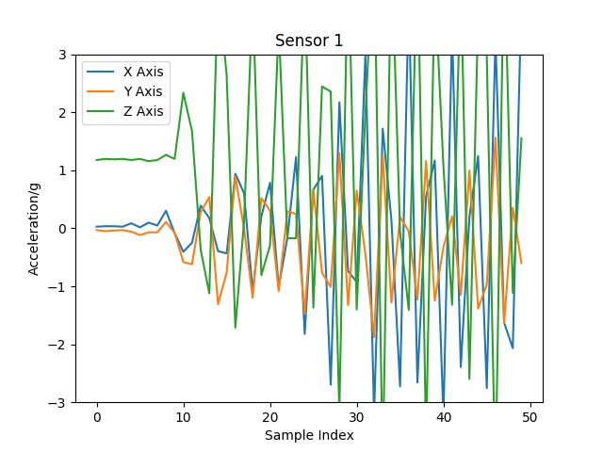

It may be good to have multiple options that the user can select and a loop that creates a reusable menu for graphing options and then further data processing. We could also attach a time rather than a sample index? Maybe important for Fourier?

## Instrumentation

Instrumentation is now complete with the addition of the AREF line. The positions are shown below:

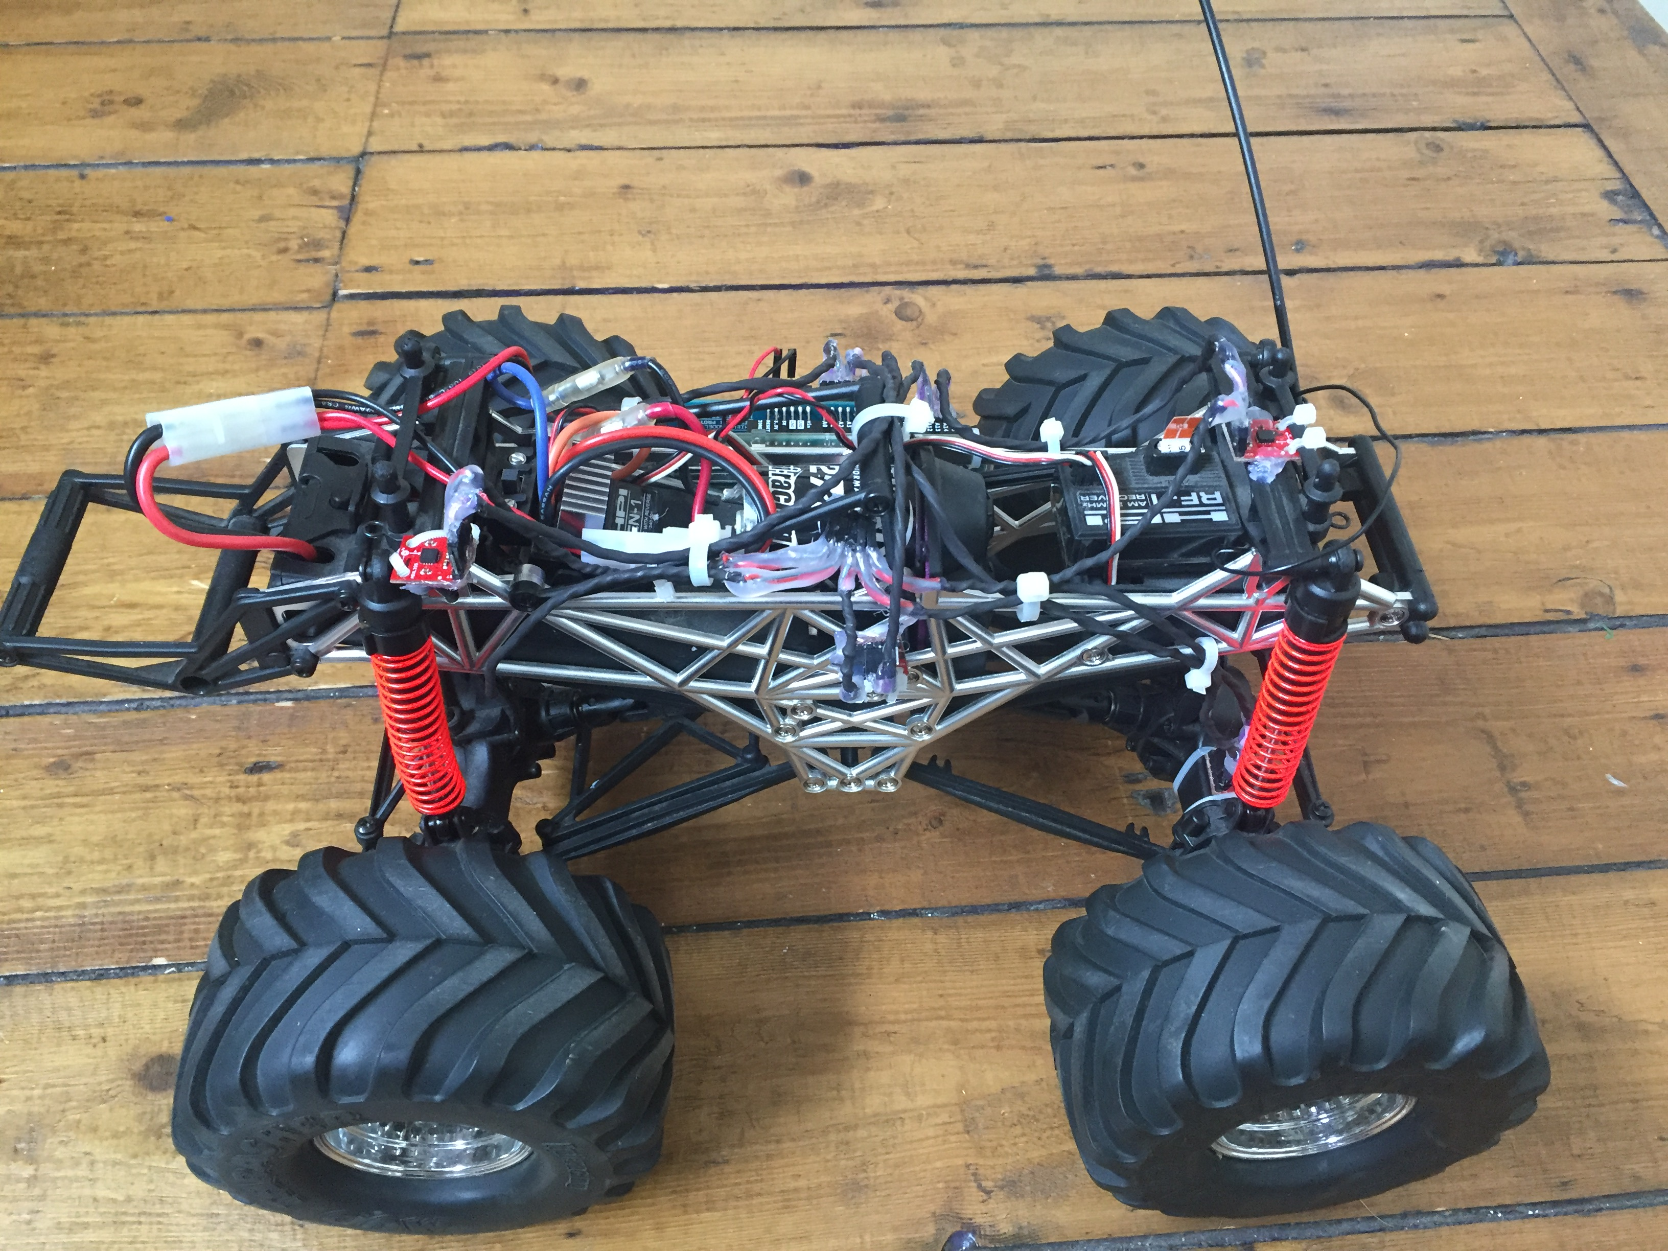

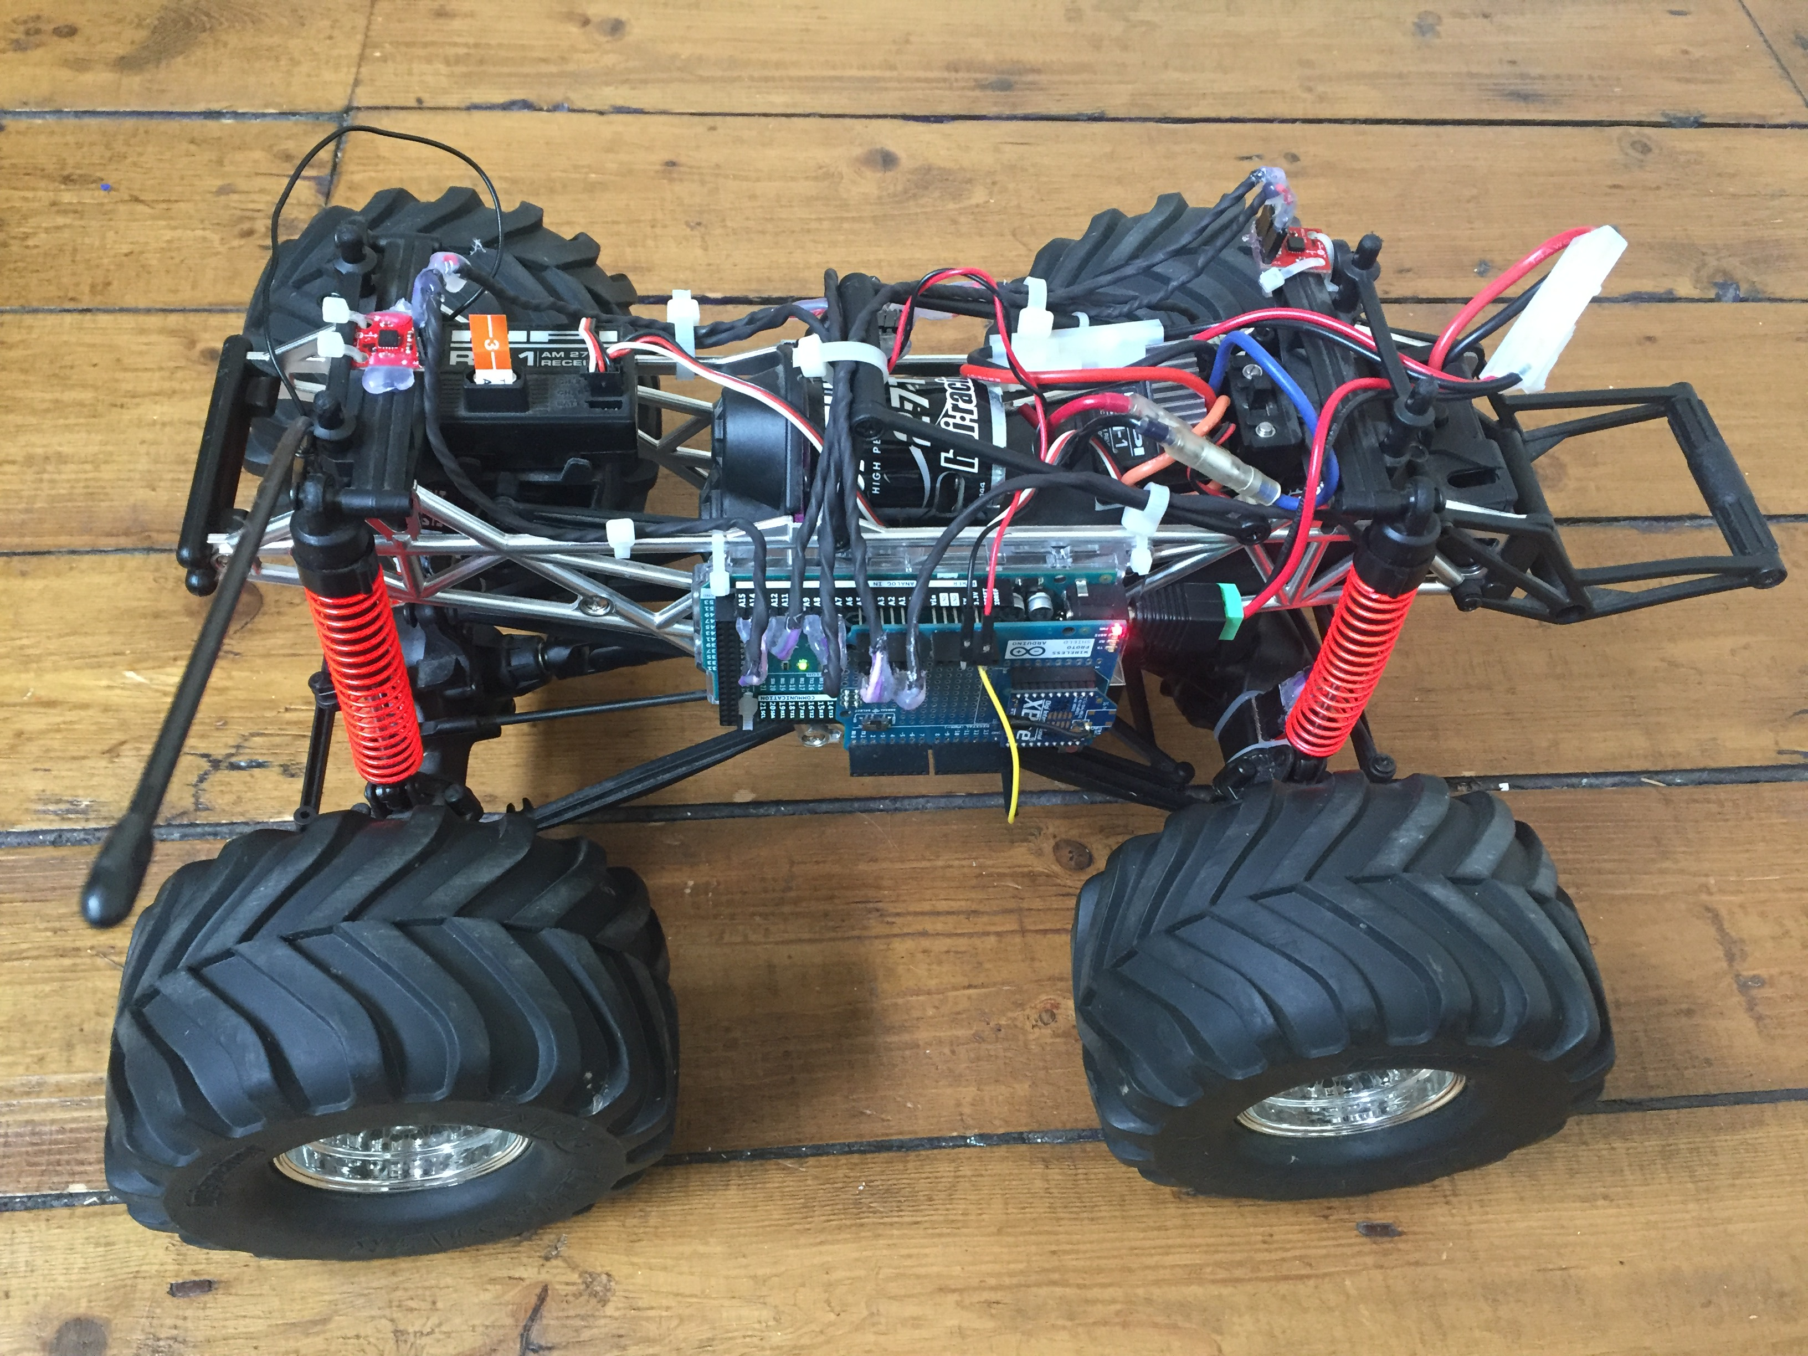

In addition, the Arduino code was altered so that the sensor numbers were associated with the correct ADC pins.

Testing with a stationary car gave the following graphs:

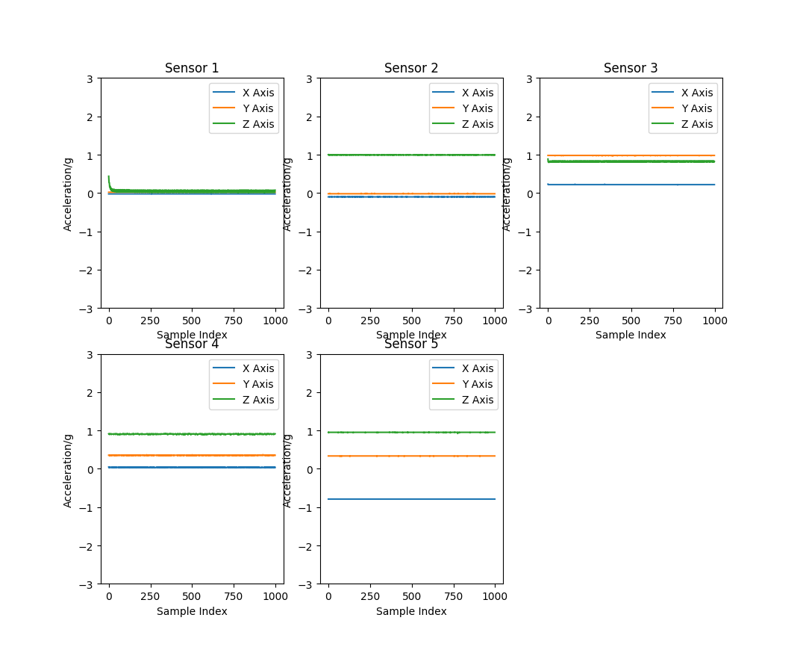

Sensor 1 Z axis seems to have an issue and the X Axis on sensor 5 seems to be -1 less than expected. Every other trace seems to be more or less as expected as the sensors are not mounted exactly parallel to gravities axis. One of sensor 5’s calibration values was incorrect. Once altered it fixed the issue with sensor 5:

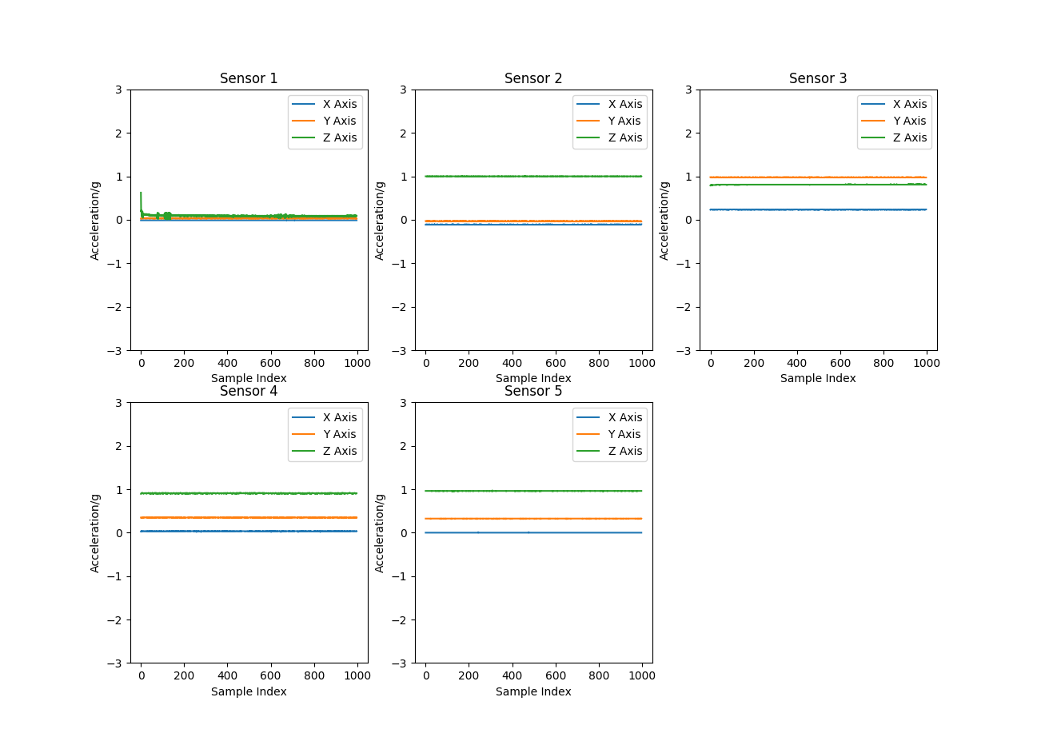

Sensor 1 Axis Z seems like it is unconnected and so there may be a problem with the connection. Ill test this by using a different wire. The wire makes no difference but switching in a fresh sensor alters the graph to the expected readings. Sensor 1 must therefore have a faulty Z Axis.

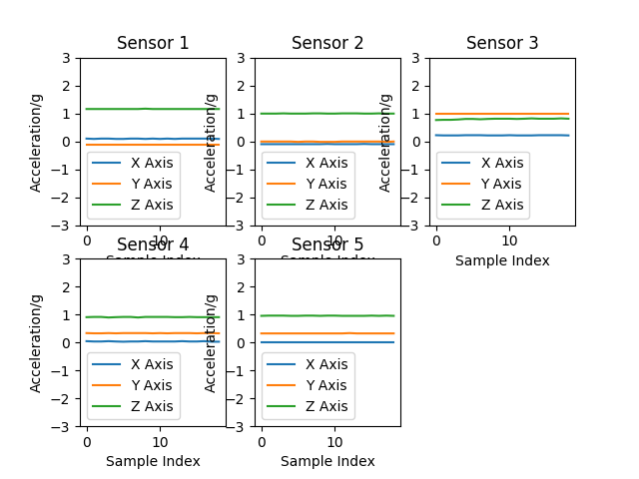

Checking Sensor 3 against the schematic also shows that the Z Axis is faulty. It should be reading 0 at this point. Switching in a fresh sensor to 3 gives:

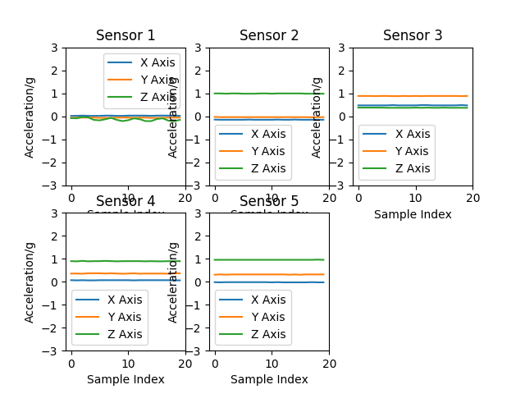

As can be seen The Z axis is now at the same as X axis which with calibration should be around 0. This means both 1 and 3 should be replaced. With only 1 spare sensor. I have ordered more but must wait to replace both. 1 can be replaced however and should be calibrated before being attached. This will be given the name 1B. Sensor 1B was therefore calibrated:

|  |  |  |
| --- | --- | --- |
| Sensor Axis | Applied Acceleration/g | Sensor 1B ADC |
| X | 1 | 611.007 |
| 0 | 509.001 |
| Y | 1 | 608.954 |
| 0 | 507.88 |
| Z | 1 | 635.991 |
| 0 | 532.93 |
|  |  |  |
|  | Co-Efficient | Sensor 1B |
|  | mX | **102.006** |
|  | mY | **101.074** |
|  | mZ | **103.061** |
|  | bX | **-4.989912358** |
|  | bY | **-5.02483329** |
|  | bZ | **-5.171015224** |

These values were used to replace sensor 1s coefficients in the python code and sensor 1B was attached to the vehicle in sensor 1s place. New Traces: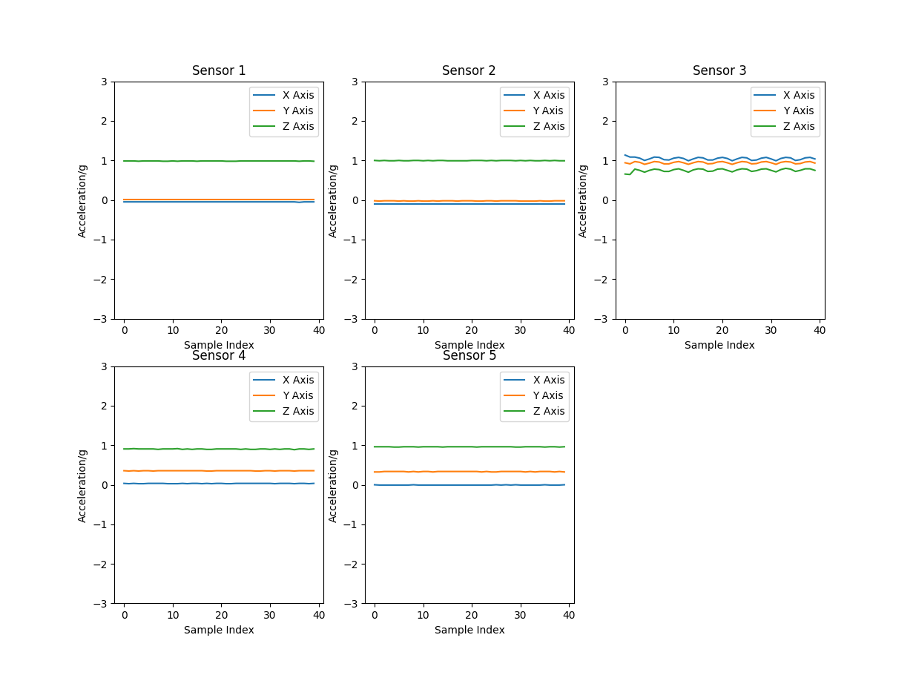

Until 3 is installed I will run a test run using the other sensors to get an idea of what traces will look like.

## Code

To aid with data display and manipulation a menu was added with the ability to view the data in different formats and select between ADC and g format:

# This loop allows the user to look at the data in various formats before exiting the program

    while(finish == '0'):

        # Allows the choice between using the data as in ADC or g format

        dataSelection = input('Which data do you want to use:\n0:ADC\n1:g\n')

        if (dataSelection == '0'):

            data = np_data_sorted

        elif(dataSelection == '1'):

            data = np_data_g

        else:

            data = np_data_g

        # Allows the choice between different display options

        selection = input('Which option:\n0:Single figure.\n1:Seperate figures.\n2:Finish\n')

        if (selection == '0'):

            plot_singlefig(data,NO_SENSORS,int(dataSelection)) # Plots all sensor graphs in one figure

        elif (selection == '1'):

            plot_multifig(data,NO_SENSORS,int(dataSelection)) # Plots each sensor graph in a seperate figure one after the other

        elif (selection == '2'):

            finish = '1'

This also incorporates the previously produced graphs.

## Further Goals

* Replace Sensor 3
* Attach Motors and test with Arduino.
* Test Run.
* Data Processing. Fourier? Time Stamp for samples required?
* Fault Scenarios.
* Averaging from sensors?
* Header does not have sensor max of 5?

## Data Processing

An FFT can be used to transform from time to frequency while reducing the computation required by breaking the calculation into smaller components:

<https://www.allaboutcircuits.com/technical-articles/an-introduction-to-the-fast-fourier-transform/>

This seems like a good place to start as the frequency response can be broken into frequency bins for the neural network. I believe that the addition of sampling time will be required to create a Fourier transform so this is the next goal.

Using the millis() function the Arduino can return the time since the program started. By minusing the time when each sample is taken from the start time the current time stamp for each sample can be acquired.

This is then sent with the readings to the PC.

timeStart = millis();

while(start){

for(int i=0; i<NO_OF_SENSORS; i++){

timeSample = millis()-timeStart;

Serial.print(i+1);

Serial.print(" ");

Serial.print(analogRead(sensorInfo[i][0]));

Serial.print(" ");

Serial.print(analogRead(sensorInfo[i][1]));

Serial.print(" ");

Serial.print(analogRead(sensorInfo[i][2]));

Serial.print(" ");

Serial.print(timeSample);

Serial.print(" ");

delay(20);

Serial.println();

The python code was then updated to include the extra field in the data packet and tag it on to the end of a sensors readings. It was also used in the graphs as the x axis info in place of the index.

Testing showed an increased number of packet errors however, this may be due to the increased length of the timestamp as its in milliseconds. An increased delay after the timeSample is sent seems to confirm this by reducing errors until the value sent becomes greater than 100,000. Increasing the delay further or changing to milliseconds may fix this. After testing the following delay distribution effectively prevents packet loss even past 100,000 milliseconds:

while(start){

for(int i=0; i<NO_OF_SENSORS; i++){

timeSample = millis()-timeStart;

delay(1);

Serial.print(i+1);

delay(1);

Serial.print(" ");

delay(1);

Serial.print(analogRead(sensorInfo[i][0]));

delay(1);

Serial.print(" ");

delay(1);

Serial.print(analogRead(sensorInfo[i][1]));

delay(1);

Serial.print(" ");

delay(1);

Serial.print(analogRead(sensorInfo[i][2]));

delay(1);

Serial.print(" ");

delay(1);

Serial.print(timeSample);

delay(20);

Serial.print(" ");

delay(1);

Serial.println();

As this is a simpler solution than sending seconds and has better time resolution this will be used going forward. A test that ran for 10 minutes, equivalent to around 20000 samples at about 30ms per sample, which will be used as a time window to collect samples from the car ran without packet loss so it seems to be an effective solution.

The only issue is the graphs x axis stopping at 60 for some reason. Testing showed that the float type float16 was too small and was causing the /1000 operation to give inf as an answer. Float 32 is now used.

The next step is to implement the fourier transform. This will be easiest to test with real data and so sensor 3b will be attached.

## Replace Sensor 3

Sensor 3b was calibrated:

|  |  |  |
| --- | --- | --- |
| Sensor Axis | Applied Acceleration/g | Sensor 3B ADC |
| X | 1 | 607.194 |
| 0 | 509.436 |
| Y | 1 | 604.12 |
| 0 | 499.752 |
| Z | 1 | 644.881 |
| 0 | 541.344 |
|  |  |  |
|  | Co-Efficient | Sensor 3B |
|  | mX | **97.758** |
|  | mY | **104.368** |
|  | mZ | **103.537** |
|  | bX | **-5.211194992** |
|  | bY | **-4.78836425** |
|  | bZ | **-5.228507683** |

These values were switched for the tables current values and sensor 3b was placed on the car in 3s location. A test shows:

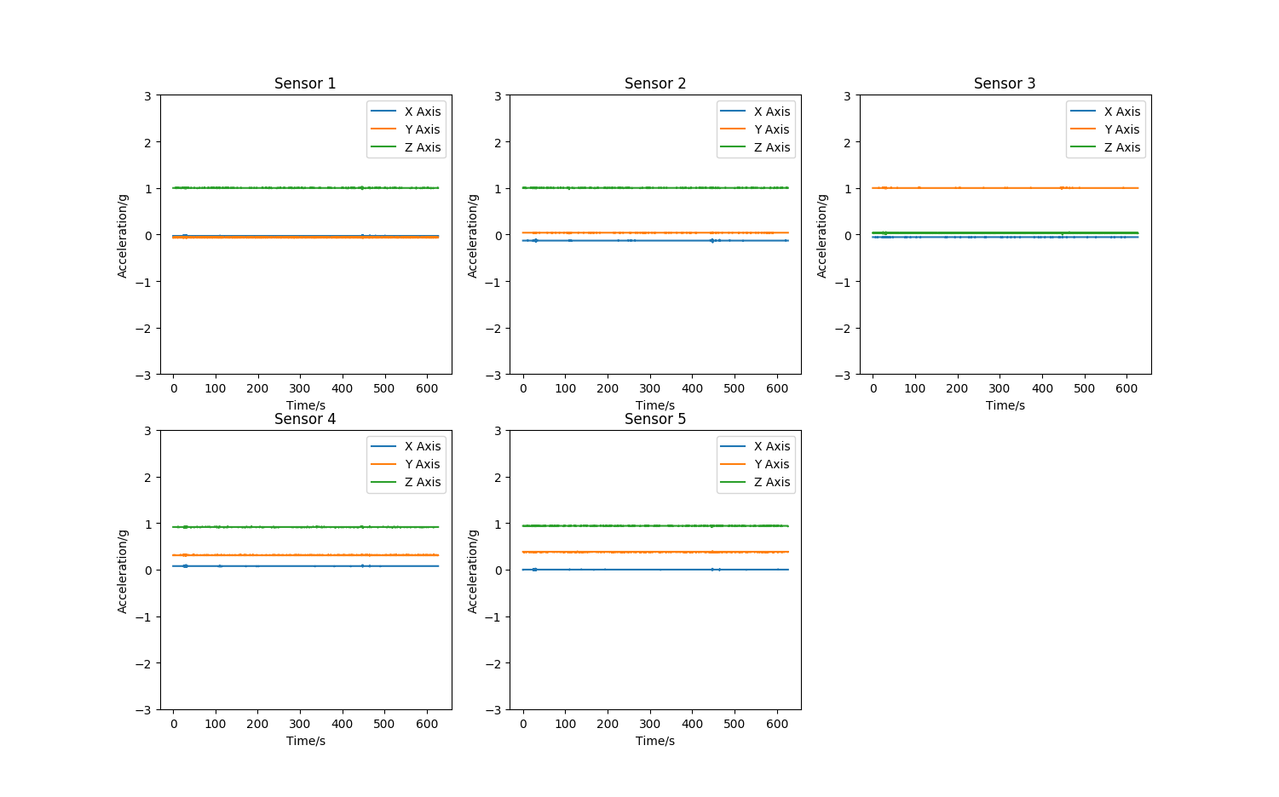

All sensors are now operating as expected. Although the calibration of 1 and 3 seems more effective than the others so that may have to be revisited. Sensor 4 and 5 are not however on flat axis so they should not be at exactly 0 anyway.

## Data Processing

Once real data has been collected it should be possible to access saved data in the code to perform further analysis so the next step will be to add this feature and make sample collection optional.

The option was added to either collect samples or go straight to data analysis. Currently this has some similar options to the sample manipulation menu but this may be changed at a later point and amalgamated into one manipulation section. The manipulation section now reads given path and returns the saved data as an array:

 if (modeSelect == '1'):

        # Read out the data from scecified file

        saved_data = read_csv(currentPath)

        # Remove the header and convert the data to a float32 numpy array for manipulation

        np_saved_data = np.array(saved_data[2:]).astype(np.float32)

        # This loop allows the user to look at the data in various formats before exiting the program

        while(finish == '0'):

            # Allows the choice between different display options

            selection = input('Which option:\n0:Single figure.\n1:Seperate figures.\n2:Finish')

            if (selection == '0'):

                plot_singlefig(np_saved_data,NO_SENSORS,1) # Plots all sensor graphs in one figure

            elif (selection == '1'):

                plot_multifig(np_saved_data,NO_SENSORS,1) # Plots each sensor graph in a seperate figure one after the other

            elif (selection == '2'):

                finish = '1'

The Fourier transform will be performed in this section and the results can also be saved from here.

Before the data can be transformed the data is interpolated since the sample period was not constant. After talking to Martin this may be possible to alter with the way the samples are collected and sent but for now interpolation was used. This meant creating a new time array for each sensor with the same start and end times but with a constant interval between the start and end times. This was done using linspace and the interp functions:

 # Read out the data from scecified file

        saved_data = read_csv(currentPath)

        # Remove the header, select a portion of data and convert the data to a float32 numpy array for manipulation

        np_saved_data = np.array(saved_data[2:1802]).astype(np.float32)

        # Create a copy of the data for interpolation

        np_interpol_data = np_saved_data.copy()

        # Interpolate the data

        for i in range(0,NO_SENSORS):

            # Create a time array fopr each sensor that has the same start and end time as the data but with a constant interval

            np_temp = np.linspace(0,np_interpol_data[-1][3+(i*4)],np_interpol_data.shape[0])

            for j in range(0,3):

                # Use the constant interval time data to interpolate the corresponding x,y and z values from the original data

                np_interpol_data[:,j+(4*i)] = np.interp(np_temp,np_interpol_data[:,3+(i*4)],np_interpol_data[:,j+(i*4)])

            # Replace the original sample times with the constant interval sample times for each sensor

            np_interpol_data[:,3+(i*4)] = np_temp

        # Save the interpolated data to CSV

        save_as_csv(pathName+'(Interpolated).csv',np_interpol_data,NO_SENSORS)

Then the new data is transformed using the FFT function and the fftfreq function to obtain the frequency values corresponding to each frequency component.

 # Create a copy of the interpolated data for FFT

        np_fft_data = np_interpol_data.copy()

        # Perform an FFT on the X,Y and Z values for each sensor and save the magnitude

        for i in range(0,NO_SENSORS):

            for j in range(0,3):

                np_fft_data[:,j+(4*i)] = abs(fftpack.fft(np_fft_data[:,j+(4*i)]))

        # Get number of samples

        N = np_fft_data.shape[0]

        # Get the time interval for each sensor

        dt = np_fft_data[[1],[3,7,11,15,19]] - np_fft_data[[0],[3,7,11,15,19]]

        print(dt)

        # Find the smapling frequency for each sensor

        fs = 1/dt

        # Produce the frequency data corresponding to the FFT

        for i in range(0,NO_SENSORS):

            np_fft_data[:,3+(i*4)] = fftpack.fftfreq(N) * fs[i]

        # Remove values above the Nyquist Frequency N/2

        np_ffthalf_data = np_fft_data[:int(N/2)]

        # Plot the FFT values

        plt.figure(1)

        for i in range(0,NO_SENSORS):

            # The figure is seperated into subplots using the parameter. 231 means 2 rows, 3 columns, subplot 1

            plt.subplot(231 + i)

            plt.title('Sensor ' + str(i + 1))

            plt.plot(np_ffthalf_data[:,(3 + (4 * i))],np_ffthalf_data[:,(0 + (4 * i))],label='X Axis')

            plt.plot(np_ffthalf_data[:,(3 + (4 * i))],np_ffthalf_data[:,(1 + (4 * i))],label='Y Axis')

            plt.plot(np_ffthalf_data[:,(3 + (4 * i))],np_ffthalf_data[:,(2 + (4 * i))],label='Z Axis')

            plt.xlabel('Freq/Hz')

            plt.ylabel('Magnitude')

            plt.legend()

        plt.show()

        # Save the FFT values to CSV

        save_as_csv(pathName+'(FFT).csv',np_ffthalf_data,NO_SENSORS)

This took a long time to get my head round but it seems the FFT function returns an array that has the same number of elements as the input array, only half of these values should be used however due to the Nyquist frequency. Anything above the first half of the samples are symmetric frequencies. To get the corresponding frequency values to the returned FFT values the sampling frequency should be multiplied by the result of the fftfreq function.

<https://www.safaribooksonline.com/library/view/elegant-scipy/9781491922927/ch04.html>

<http://ericstrong.org/fast-fourier-transforms-in-python/>

The result is as follows:

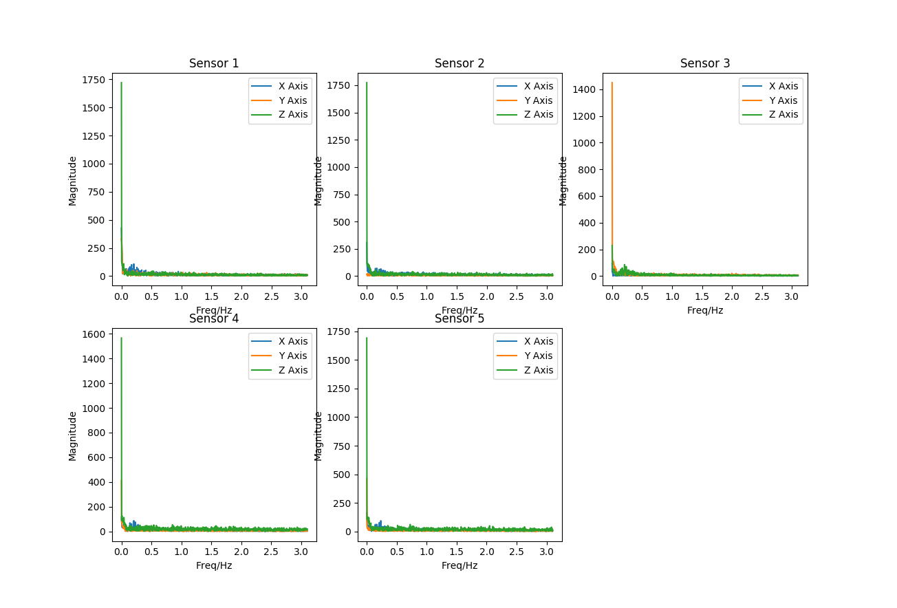

The evident problem being that with the current sampling frequency of around 6Hz it is only possible to detect frequencies up to 3Hz which is not sufficient. This means that the method of gathering signals must be adjusted or something other than a Fourier transform must be used.

## Test Run

A 10-minute test run was performed. The only hitch was the car tipping and bending some of the pins of sensor 1. It was repairable but leads to the possibility of adding roll protection. The data is saved as NormalOperation-10min-6HzSampling.csv

The interpolated and Fourier versions of the data were also saved.

## Further Goals

* Attach Motors and test with Arduino.
* Faster sampling rate.
* Fault Scenarios.
* Averaging from sensors?
* Header does not have sensor max of 5?

## Faster Sampling Rate

Looking back at the examples in the initial report it seems clear that 10 minutes are not required. In fact the sample lengths of 1 second and 0.8 seconds. This may therefore be a sufficient sample length and will mean it may be possible to sample and then send after 1 second of samples have been collected.

In terms of the sample rate, it must be double that of the frequencies that need to be observed. Jafarian samples at 50kHz which is quite fast. This factor also depends on the frequency produced by the motors so that is also important information.

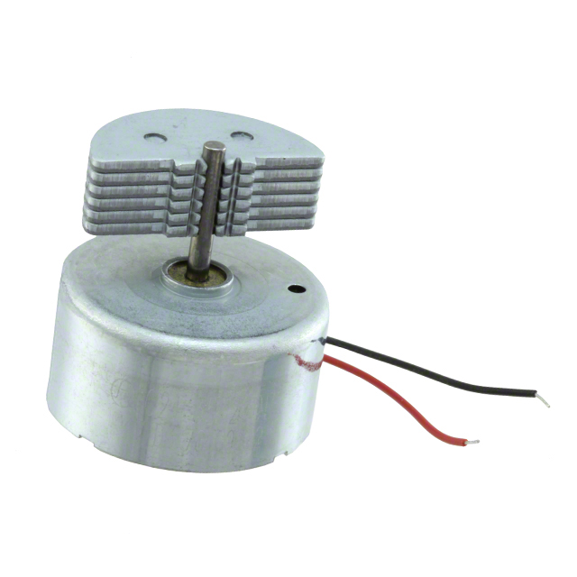

JQ24-35K270B 5V ERM

This can take between 4V-8V and has an RPM of 4250 which in Hz is 70.8Hz

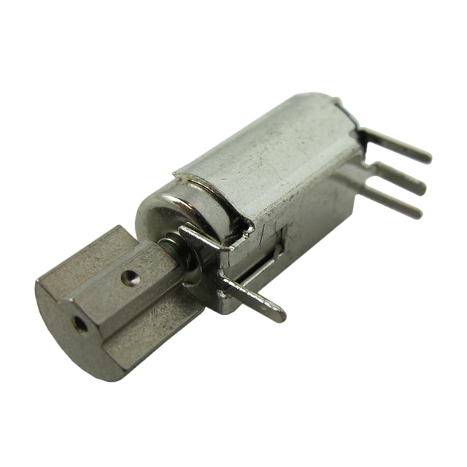Z6DCBB0735091 3V ERM

Seems to be 1.6V-3V and has an RPM of 7000+-2000 so 116Hz+-33Hz

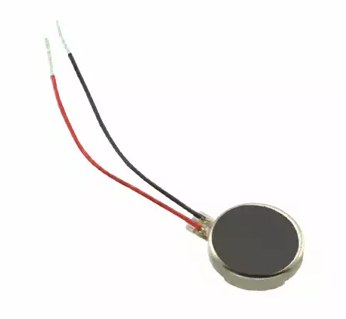1201 5V

2V to 5V and 11000RPM or 183Hz

Z4TL2B124064X 3V

2.2V-3.6V and 15,000+-2500RPM or 250Hz+-41.6Hz

In terms of the motors then, I need to be able to detect at most 300Hz so 600 samples per second if possible. Any higher than this would be better to detect additional components but this should be the lower limit if possible.

Read ADC is 100us and currently 30ms of delay for each sensor to send the data.

So 30.3ms for each sensor and 151.5ms sampling period or 6.6Hz sampling frequency.

First the majority of the delay is involved in sending the massive timestamp for 10 minute runs. If the sampling rate is faster and we keep it to a second of data, this will not be a problem. 1 second is only 1000ms which should be less of a problem so we can reduce this value significantly.

After some research I discovered that on Serial.print the data is moved to an output buffer. If a delay is not used then this can fill up and cause problems. Consequently it seems impossible to reduce the required delay from 30ms.

I therefore increased the baud rate to 115200 and this allowed the delay to be reduced to 4ms.

4.3ms for each sensor and 21.5ms sampling period or 46.5Hz sampling frequency. This is a big improvement but still not fast enough. This is also the maximum recommended baud rate.

Note 46.5Hz is the fastest sample period with 5 sensors, using less sensors or two boards would be the only way to further reduce the sampling rate.

5 Sensors – 21.5ms or 46.5Hz

4 sensors – 17.2ms or 58Hz

3 sensors – 12.9ms or 77Hz

2 sensors – 8.6ms or 116Hz

1 sensor – 4.3ms or 232Hz

Another option is to sample a block of data and then send it at the end. This requires memory however so this should be calculated. The Arduino Mega 2560 has 8K SRAM. If each sample is an integer it takes up two bytes.

A sample on each sensor for X,Y,Z is 6 bytes.

A sample on each sensor is 30 bytes.

If we conservatively assume 7K due to other variables that gives us 233 samples before sending. At 1.5ms sampling period that gives us 0.35 seconds of data at 666.6Hz or 0.7 seconds of data at 333.3Hz.

This is sufficient for the motors although it would be nice to increase this functionality further to hold more data as 0.7 seconds seems like a short period. It is very close to the 0.8 used in the paper however so maybe it is sufficient. By optimising the code it may be possible to get slightly more memory but it may not be worth the time for the trade-off.

5 Sensors – 1.5ms or 666.6Hz, 0.35s data

4 sensors – 1.2ms or 833.3Hz, 0.35s data

3 sensors – 0.9ms or 1111.1Hz, 0.35s data

2 sensors – 0.6ms or 1666.6Hz, 0.35s data

1 sensor – 0.3ms or 3333.3Hz, 0.35s data

Currently the best option seems to be using a 333.3Hz on 5 sensors for 0.7s of data or maybe 0.5s of data and see how that works and how long the serial send takes for that amount of data. There may be a nice medium between sampling time and serial downtime.

I also looked at increasing the memory with things like an SD card but this presents the problem of increasing sampling time to write the data to the card.

Version 5 of the software is complete and is functional. It currently collects 200 samples before sending the data. It may be possible to increase this slightly without overflowing the memory. To achieve this both the Arduino and python code were completely overhauled.

// Variables

const int NO_OF_SENSORS = 5;

const int NO_OF_SAMPLES = 200;

const int sensorInfo[5][3] = { {sensor1x,sensor1y,sensor1z},

{sensor2x,sensor2y,sensor2z},

{sensor3x,sensor3y,sensor3z},

{sensor4x,sensor4y,sensor4z},

{sensor5x,sensor5y,sensor5z} };

bool start = false;

int serialRX;

unsigned int timeStart,timeEnd;

int sensorVals[NO_OF_SAMPLES][15];

void setup() {

Serial.begin(115200);

analogReference(EXTERNAL);

}

void loop() {

while(!start){

if (Serial.available() > 0){

serialRX = Serial.read();

if (serialRX == 'S'){

start = true;

}

}

}

while(start){

timeStart = millis();

for(int i=0; i<NO_OF_SAMPLES; i++){

for(int j=0; j<NO_OF_SENSORS; j++){

// Takes 100 microseconds per analogue read plus added delay

sensorVals[i][0+(j*3)] = analogRead(sensorInfo[j][0]);

delayMicroseconds(100);

sensorVals[i][1+(j*3)] = analogRead(sensorInfo[j][1]);

delayMicroseconds(100);

sensorVals[i][2+(j*3)] = analogRead(sensorInfo[j][2]);

delayMicroseconds(100);

}

}

timeEnd = millis()-timeStart;

for(int i=0; i<NO_OF_SAMPLES; i++){

for(int j=0; j<NO_OF_SENSORS; j++){

Serial.print(sensorVals[i][0+(j*3)]);

Serial.print(" ");

Serial.print(sensorVals[i][1+(j*3)]);

Serial.print(" ");

Serial.print(sensorVals[i][2+(j*3)]);

Serial.print(" ");

delay(4);

}

Serial.println();

}

Serial.print(timeEnd);

Serial.print(" ");

Serial.println();

if (Serial.available() > 0){

serialRX = Serial.read();

if (serialRX == 'S'){

start = false;

}

}

}

}

The main difference is the use of an array to sample the values, the increased baud rate and the data packet which is now sent in the format: X1,Y1,Z1,X2,Y2,Z2......X5,Y5,Z5

Neither ID or timestamp are required as the format makes the ID clear and the end time is now sent after the data. Since serial communications are not used during ADC sampling, sampling time should now be guaranteed as constant.

The biggest change to the python code is the sampling function:

 run = '1'

    badSamples = 0

    count = 1

    log_temp = []

    temp = [0] * 20

    NO_FIELDS = (NO_SENSORS * 3) + 1

    while (run == '1'):

        # If the input buffer is not empty read the data out into rawData using \n as a delimiter.

        if (serialPort.inWaiting()>0):

            rawData = serialPort.readline()

            print(rawData)

            # If invalid data is recieved this prevents program crash

            try:

                # Decode the bytes into a string

                data = rawData.decode()

                # Split x, y, z and newline values into a list

                if (count >= (NO_SAMPLES + 1)):

                    endTime_temp = data.split(" ", 2)

                    if (len(endTime_temp) == 2 and '' not in endTime_temp):

                        endTime = int(endTime_temp[0])

                    else:

                        endTime = 1625

                    print('Lost Samples: ' + str(badSamples))

                    run = '0'

                else:

                    data_readings = data.split(" ", NO_FIELDS)

                    print(data_readings)

                    # A correct sample should contain 16 values and not include null and so this is used

                    # to validate the data and record any samples that are discarded in this way

                    if (len(data_readings) == NO_FIELDS and '' not in data_readings):

                        # Discard newline characters before saving data

                        int_data_readings = list(map(int,data_readings[:(NO_FIELDS - 1)]))

                        log_temp.append(int_data_readings)

                    else:

                        badSamples += 1

            except:

                print('Invalid data recieved')

            count += 1

    samplingPeriod = (endTime/NO_SAMPLES)/NO_SENSORS

    timeStamp = 0.0

    for i in range(0,len(log_temp)):

        for j in range(0,NO_SENSORS):

            temp[0+(j*4)] = log_temp[i][0+(j*3)]

            temp[1+(j*4)] = log_temp[i][1+(j*3)]

            temp[2+(j*4)] = log_temp[i][2+(j*3)]

            temp[3+(j*4)] = timeStamp

            timeStamp += samplingPeriod

        log.append(temp.copy())

It now takes a fixed number of samples to match the Arduino, later this could be sent during initialisation possibly. Ignore commenting which is not updated here.

The code had to be changed to handle the new data format and on the 200th sample it collects the final time.

This is then used to create the time axis data for each sensor and it is assumed the sampling period is constant. This makes the sampling function more complicated but as the data is already sorted, formatted and guaranteed to be the same length it means a number of other data handling functions could be removed.

Interpolation is also no longer required.

The new FFT data is shown.

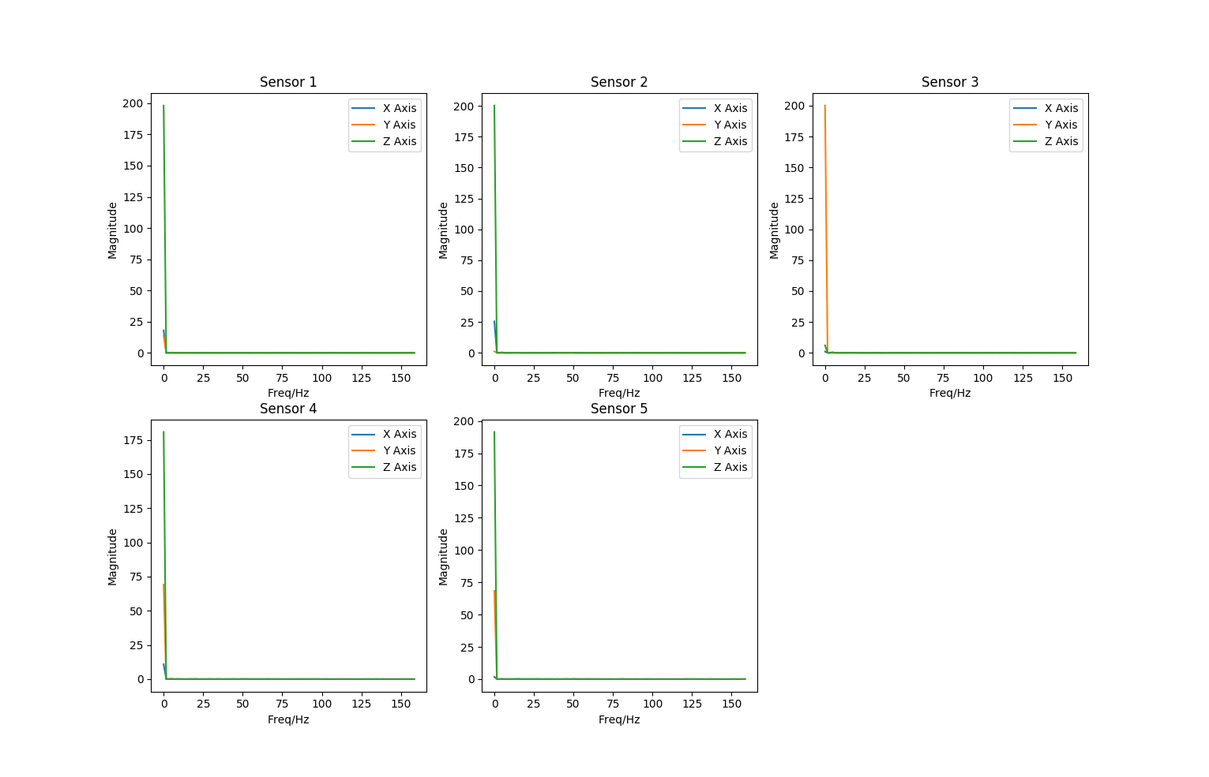

As expected a stationary vehicle has only a DC component and the frequency can now be measured up to 160Hz. This can also be doubled at the expense of a smaller collection time. More test data should now be gathered.

One of the biggest considerations to arise during this time is the potential need for a variable sampling frequency to focus on different areas of the spectrum. It also makes me wonder if initially the machine learning should use time data as a more complete form of the data.

## Further Goals

* Attach Motors and test with Arduino.
* Fault Scenarios.
* Averaging from sensors?
* Header does not have sensor max of 5?

## Fault Injection

First I discovered that the Arduino can handle storing 250 samples which increased the amount of time quite a bit. 0.78s is the current amount at the sampling frequency, which per sensor is currently 3.128ms or 320Hz.

A second test run shows FFTs as follows. For normal operation, 0.78 sample length and 320Hz sampling frequency:

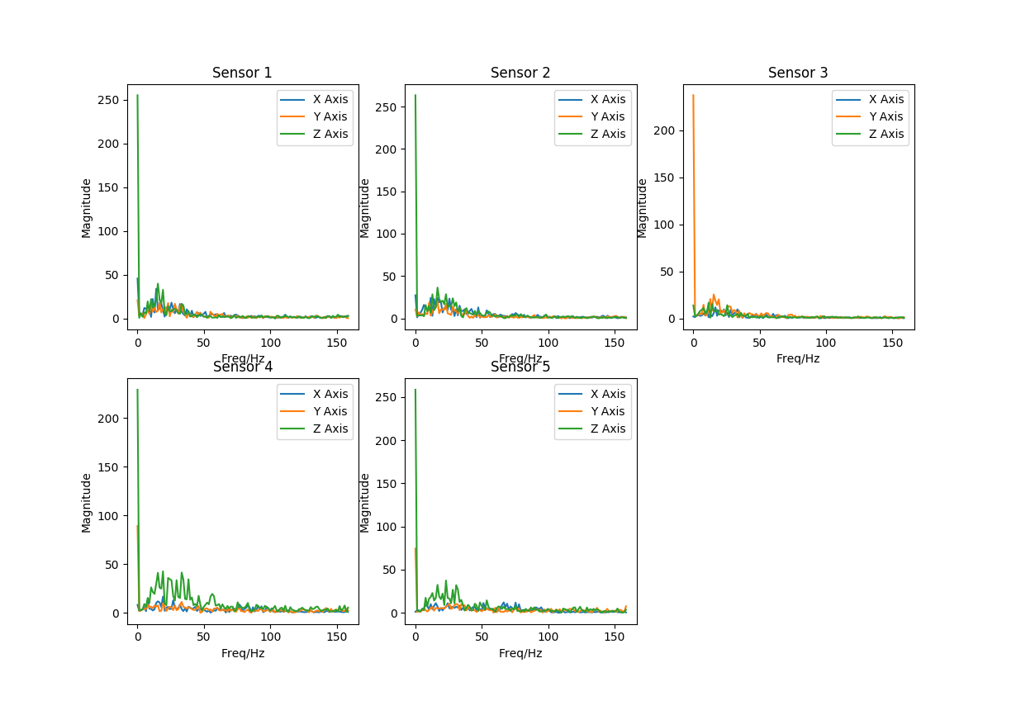

Fairly flat with some components below 50Hz. I also tested some suspension faults. With the front suspension out: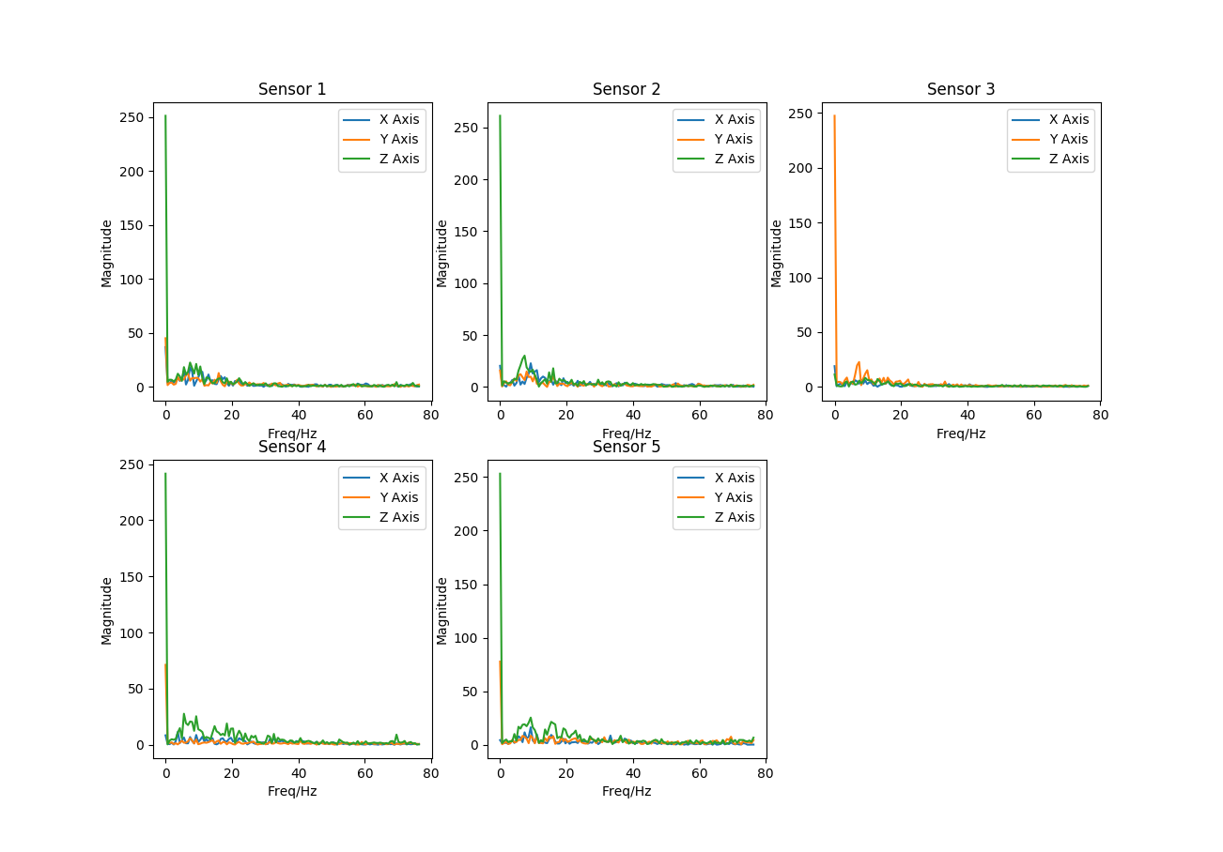

And Back:

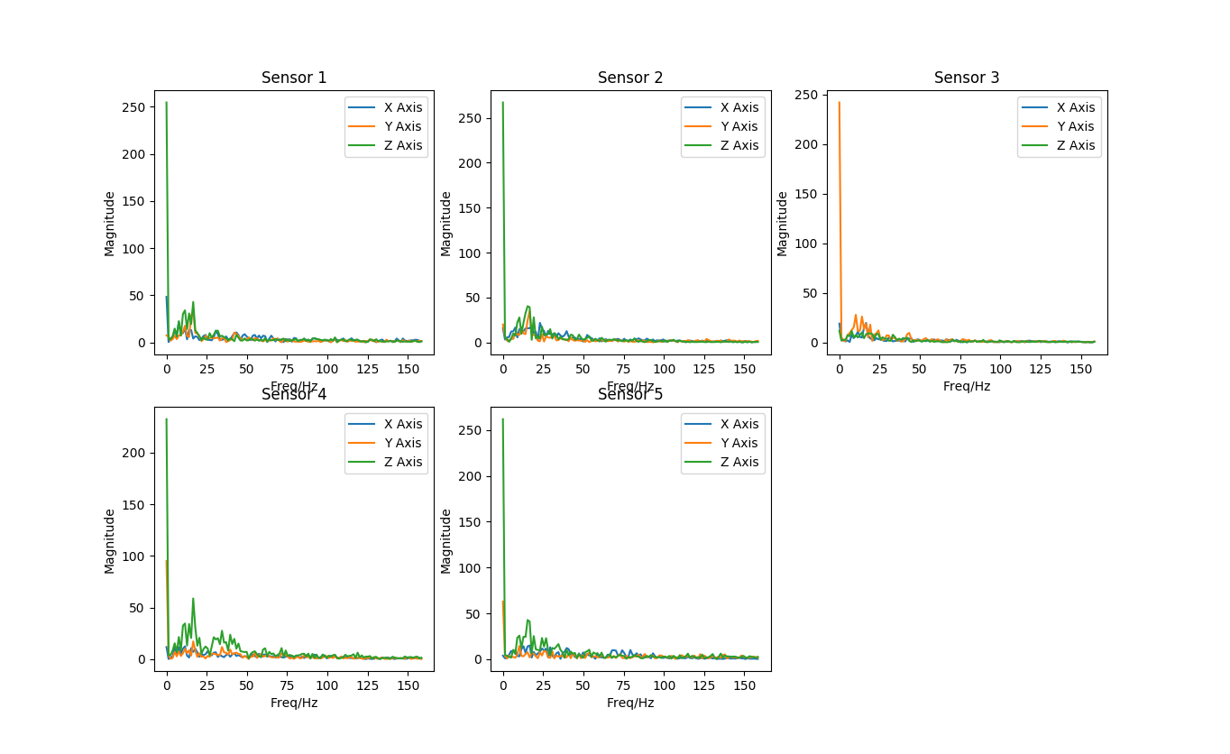

If there are differences they are subtle. It would be interesting to see if an algorithm can tell the difference. I also wonder if there are any higher frequency components. Also for comparison is the normal followed by back suspension out in the time domain.

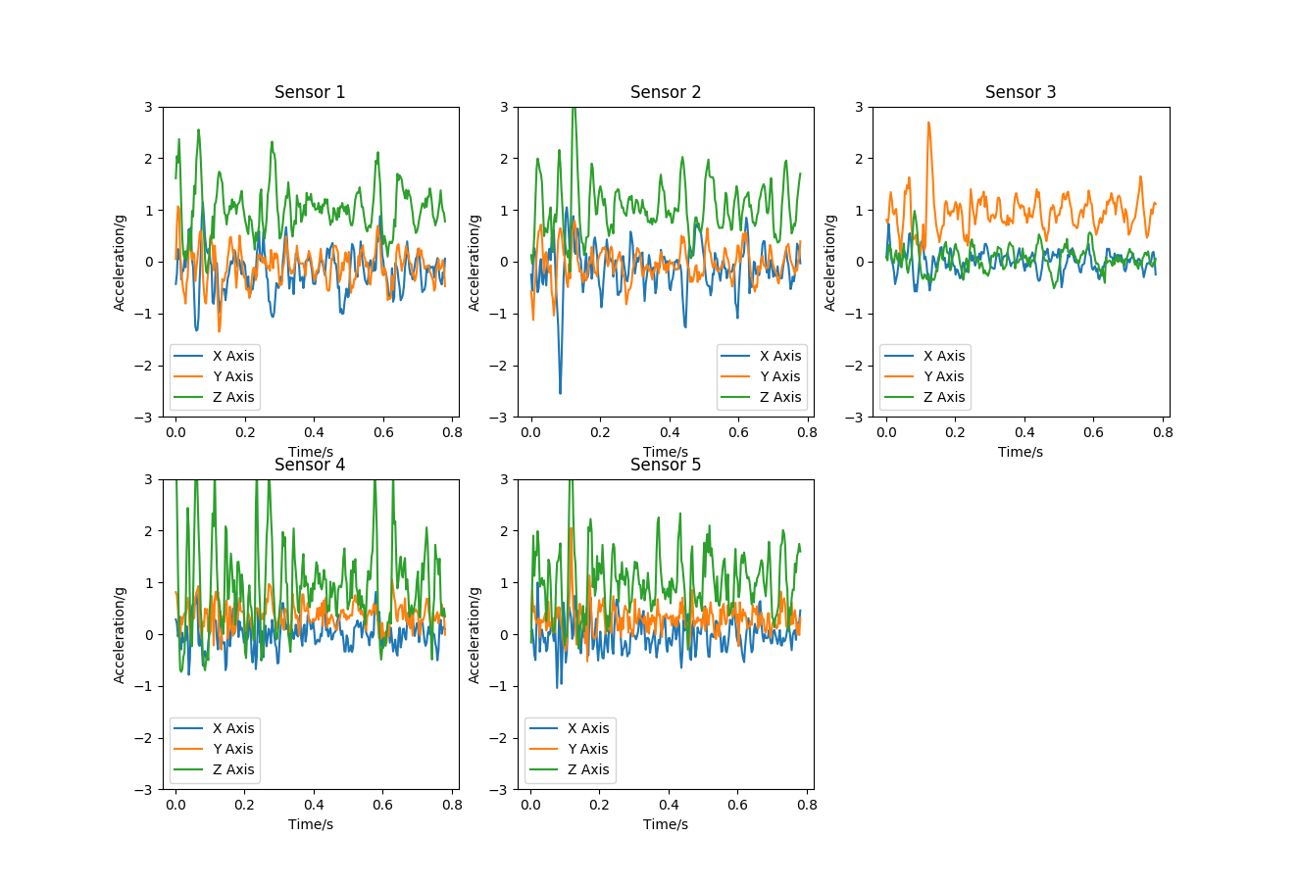

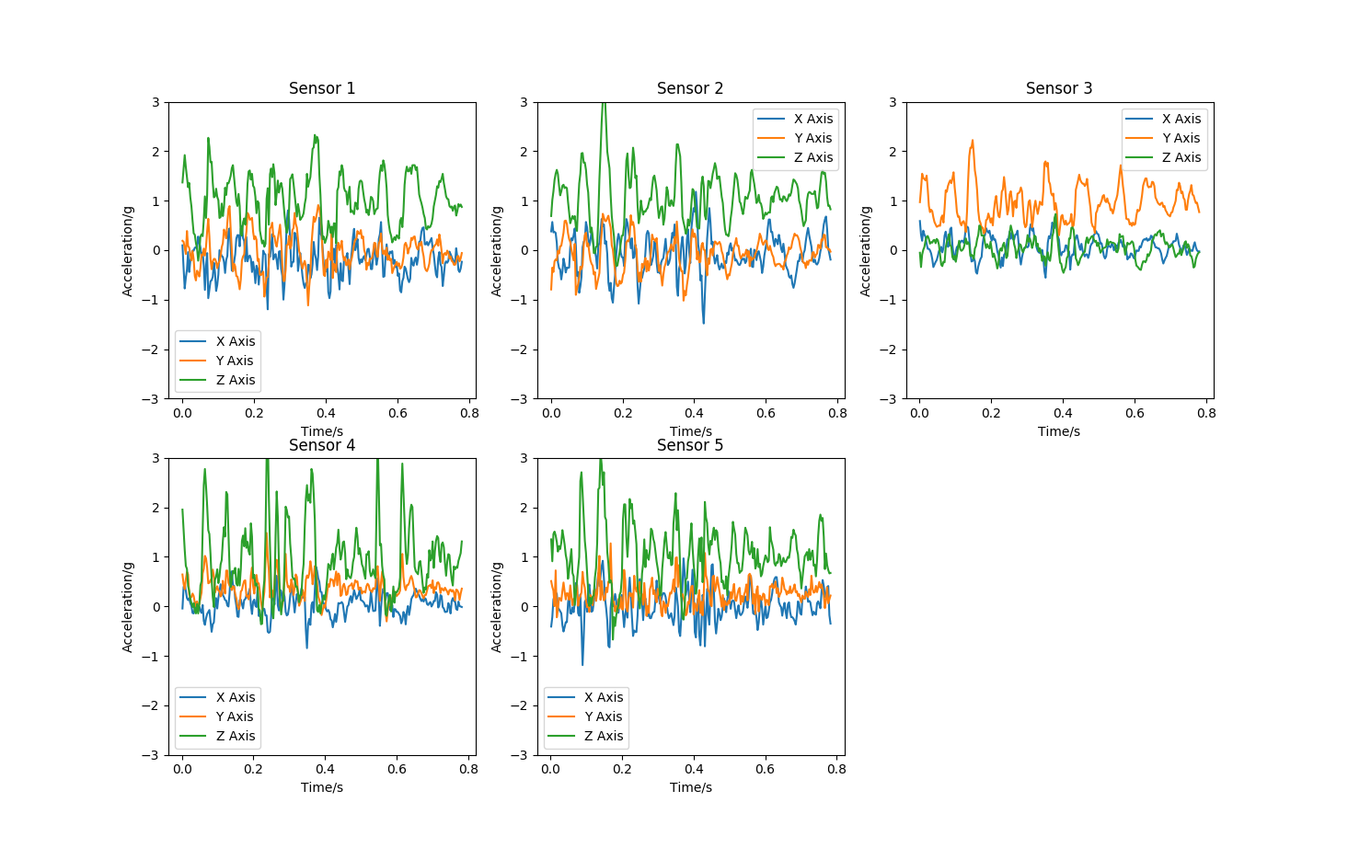

And a comparison of some normal operation FFT’s.

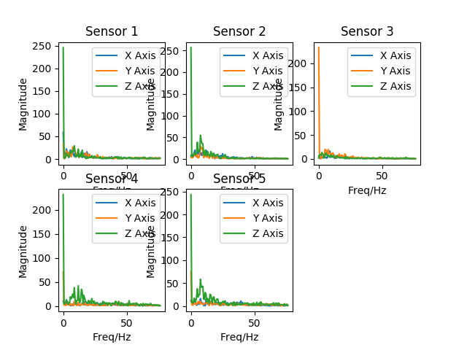

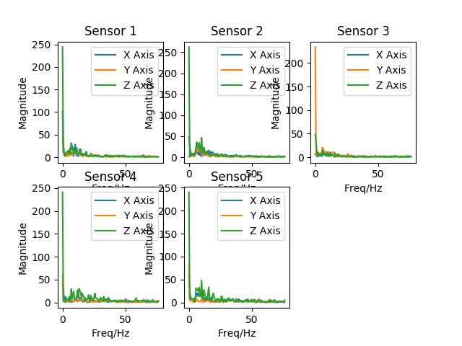

I have noticed though that a lot of the sampling cycles have halved in sampling frequency. Jumping from the expected 300Hz seen in the normal operation to 150Hz. This should be investigated. Testing showed due to desynchronization of sampling.

Two motors were attached with batteries:

5V, 60Hz – Engine cooling fan fault

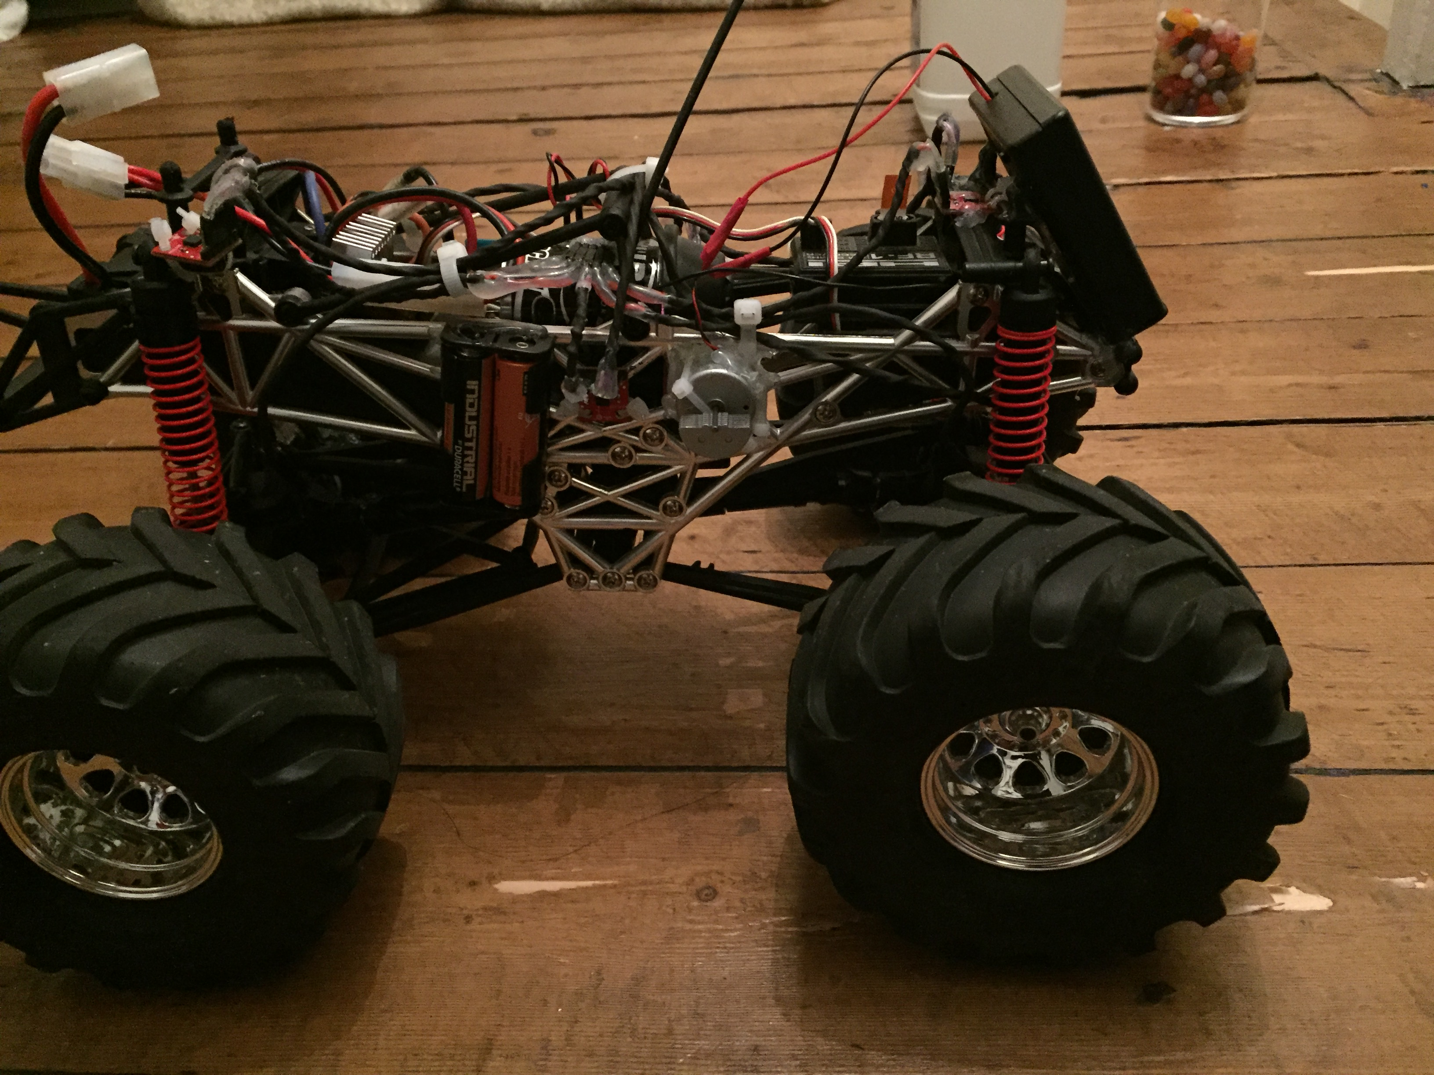

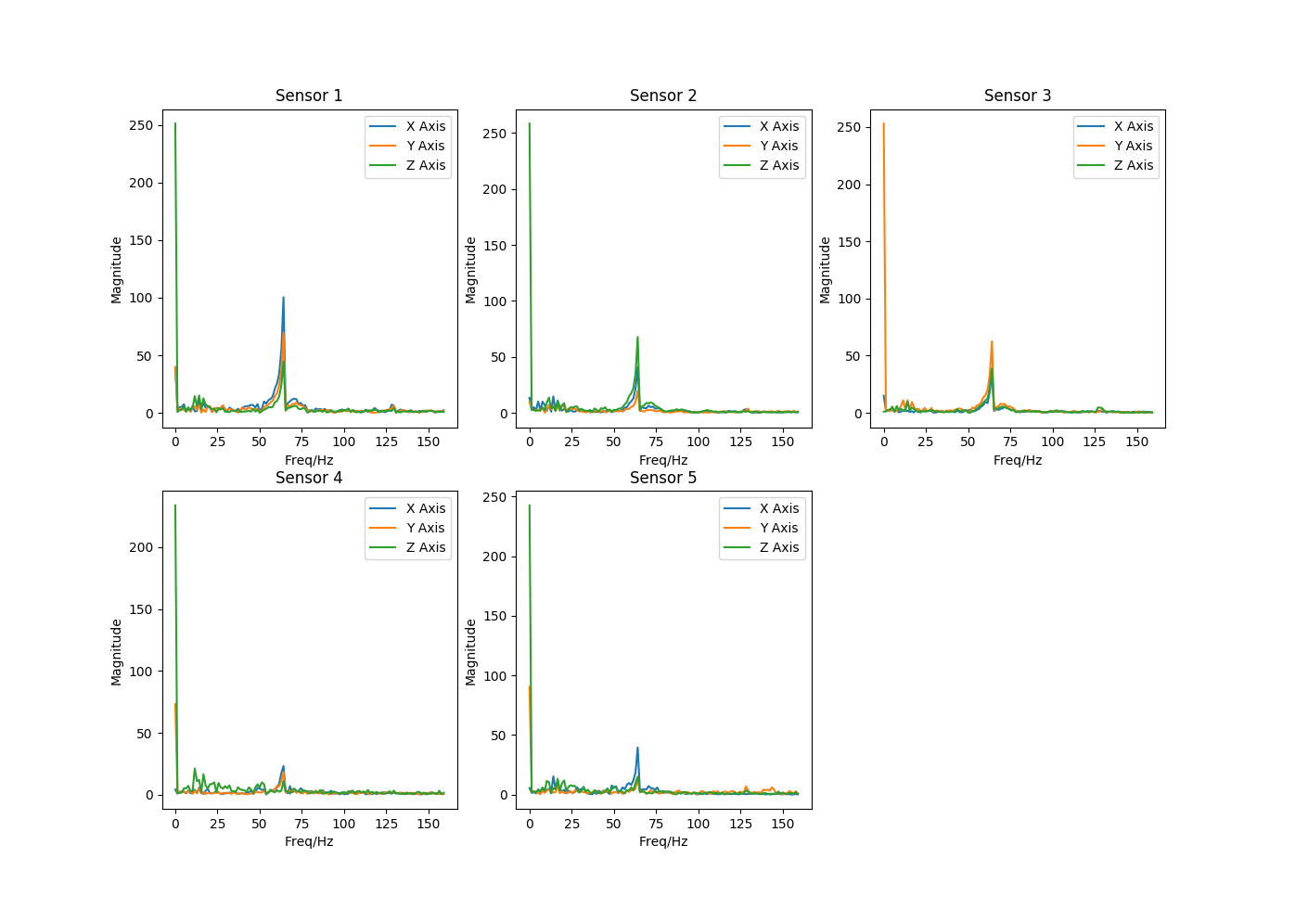

3V, 140Hz Wheel Bearing Fault

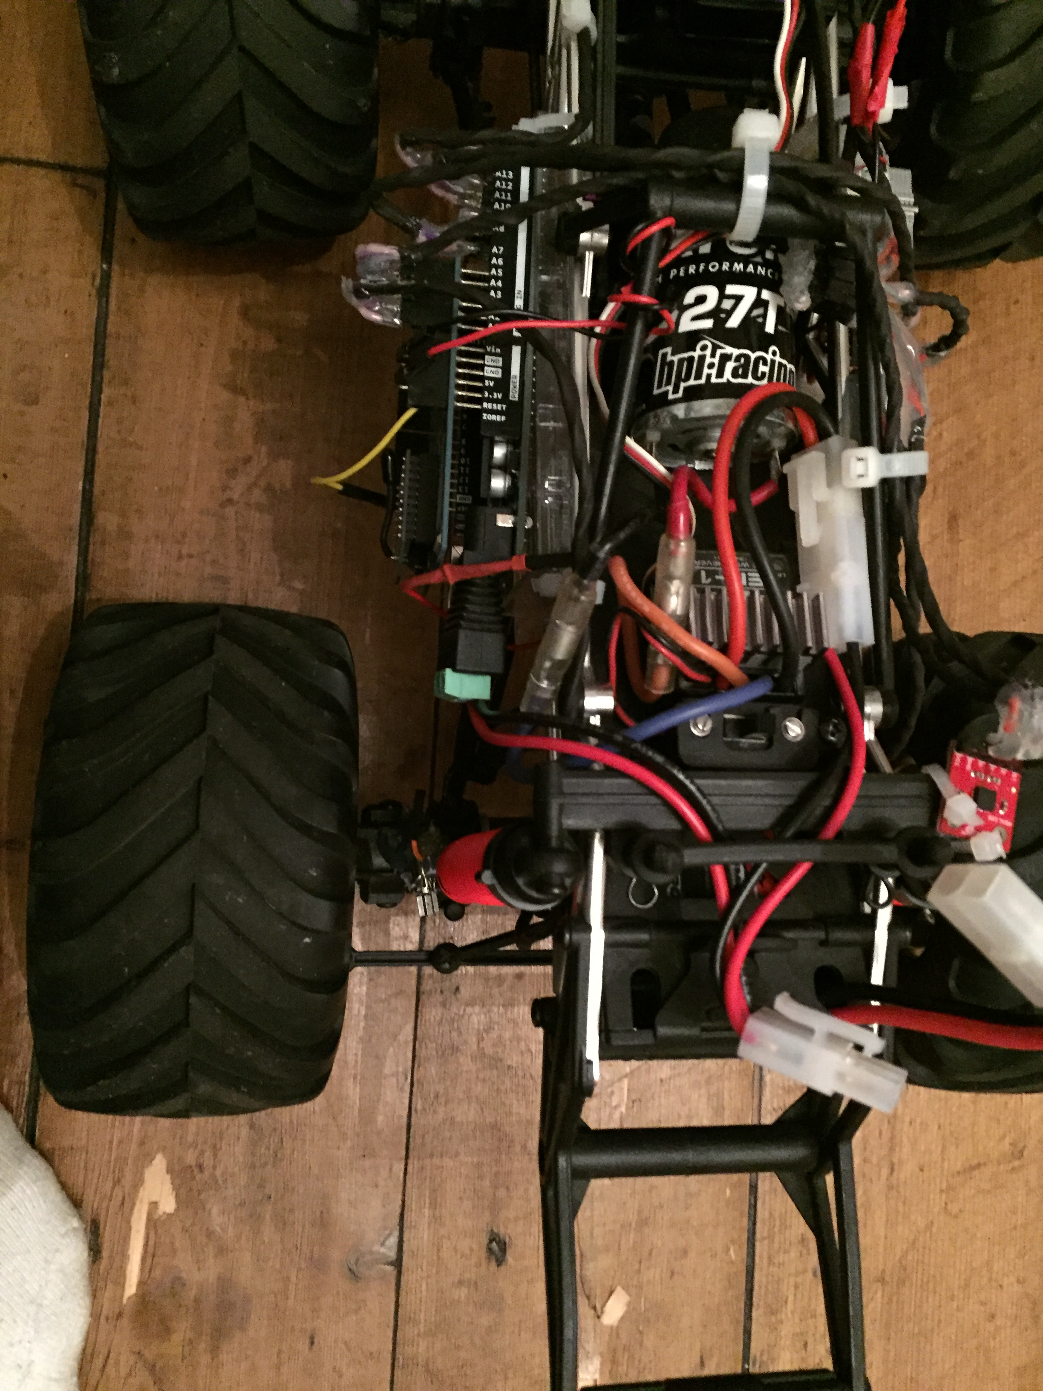



## Further Goals

* Neural Network
  + Averaging?
  + Convolution of Data
* Collect Training Data
* Calibration on car.
* Averaging from sensors?
* Header does not have sensor max of 5?

### Neural Network & Collect Training Data

First I solved the synchronisation error. The python now requests each cycle of sampling data.

To use a NN training data is required. Research shows this should be of the form, x1,x2...y where x are the inputs to the system and y is the target output.

In our case x is the frequency components from the FFT. The frequency axis data is not required, just the magnitude of each component.

First the data manipulation section was altered to create a training set. It runs through the save file locating the seeperte instances and fourier transforms them before placing the resulting instance in a log where each row is an instance that contains the frequency components of each sensors x,y,z values in order. This is a very long instance giving many inputs to the NN.

The calibration was done on the car before data was collected that calibrates when the car is stationary and saves an array to zero the axes. This can then be used each time data is collected:

# Find calibration array

        cal_path = '/Users/Angelo555uk/Desktop/University/Year_4/Project/Project/Calibration/CalArray.csv'

        if (CALIBRATE==1):

            for i in range(0,NO_SENSORS):

                for j in range(0,3):

                    calibration_array.append(np.mean(np_data_g[:,j+(4*i)]))

            with open(cal_path, 'w') as csv_file:

                csv_write = csv.writer(csv_file, dialect='excel')

                csv_write.writerow(calibration_array)

        # Re-Zero axes

        calibration_array = read_csv(cal_path)

        np_calibration_array = np.array(calibration_array).astype(np.float64).flatten()

        for i in range(0,NO_SENSORS):

            for j in range(0,3):

                np_data_g[:,j+(4*i)] -= np_calibration_array[j+(3*i)]

Data was then collected as Normal-TrainingData, Fault1-TrainingData, Fault2-TrainingData each with 25 instances. I will also collect 25 instances on the climbing car park so 100 instances 50 normal and 50 fault.

It would be helpful to visualise this data once it has been collected.

The training data section described earlier is as follows:

 targets = [1,0,0]

        training_header = []

        for i in range(0,NO_INSTANCE_TYPES):

            # Read out the data from scecified file

            saved_data = read_csv(trainingPath[i])

            # Remove the header and convert the data to a float32 numpy array for manipulation

            np_saved_data = np.array(saved_data[2:]).astype(np.float64)

            # Find start and end index of instances and total number of instances

            np_instance_start = np.asarray(np.nonzero(np_saved_data[:,3] == 0))

            np_instance_start = np.append(np_instance_start,np_saved_data.shape[0])

            numberInstances = np_instance_start.shape[0] - 1

            print (np_instance_start)

            print (numberInstances)

            # Perform FFT on each instance and save to one log

            for j in range(0,numberInstances):

                # Create a copy of the data for FFT

                np_fft_data = np_saved_data[np_instance_start[j]:np_instance_start[j+1]]

                # Perform an FFT on the X,Y and Z values for each sensor and save the magnitude

                for x in range(0,NO_SENSORS):

                    for y in range(0,3):

                        np_fft_data[:,y+(4*x)] = abs(fftpack.fft(np_fft_data[:,y+(4*x)]))

                # Get number of samples

                N = np_fft_data.shape[0]

                # Remove values above the Nyquist Frequency N/2

                np_ffthalf_data = np_fft_data[:int(N/2)]

                # Remove time rows

                np.delete(np_ffthalf_data, [3,7,11,15,19], axis=1)

                # Flatten the data into a single row

                np_temp_row = np_ffthalf_data.flatten('F')

                np_temp_row = np.append(np_temp_row,targets[i])

                temp_row = np_temp_row.tolist()

                training_log.append(temp_row)

        # Create header for training data

        for i in range (0,(len(training_log[0]) - 1)):

            training_header.append("x" + str(i))

        training_header.append("y")

        # Save the FFT Instanced values to CSV

        with open(path+'TrainingData.csv', 'w') as csv_file:

            csv_write = csv.writer(csv_file, dialect='excel')

            csv_write.writerow(training_header)

            csv_write.writerows(training_log)

This produces training data of the form:

Instance 1 - x1,x2...y

Instance 2 – x1,x2...y

.

.

Instance N - x1,x2...y

Although the training data is produced it ends up being different lengths due to packet loss while collecting the samples. Thus a dive into the communications algorithm commenced.

A lot of testing made it clear that the current method was just too unreliable so it was changed again to include an acknowledgment for each sample:

for(int i=0; i<NO_OF_SAMPLES; i++){

ack = false;

while(!ack){

for(int j=0; j<NO_OF_SENSORS; j++){

Serial.print(sensorVals[i][0+(j*3)]);

Serial.print(" ");

Serial.print(sensorVals[i][1+(j*3)]);

Serial.print(" ");

Serial.print(sensorVals[i][2+(j*3)]);

Serial.print(" ");

delay(10);

}

Serial.println();

response = false;

while(!response){

if (Serial.available() > 0){

serialRX = Serial.read();

if (serialRX == 'T'){

ack = true;

}

else if (serialRX == 'F'){

ack = false;

}

response = true;

}

}

}

}

delay(5);

Serial.print(timeEnd);

Serial.print(" ");

Serial.println();

delay(5);

start = false;

Before continuing to send the next sample the Arduino waits for an ack. If a fault occurred the python sends F and the packet is resent, otherwise a T is sent and the next packet is sent. Currently the endtime is not included in this and so this could be added.

The total samples were also reduced from 250 to 220 as strange data was being sent, a symptom of memory overload.

This prevents data loss and so each instance is now the same size:

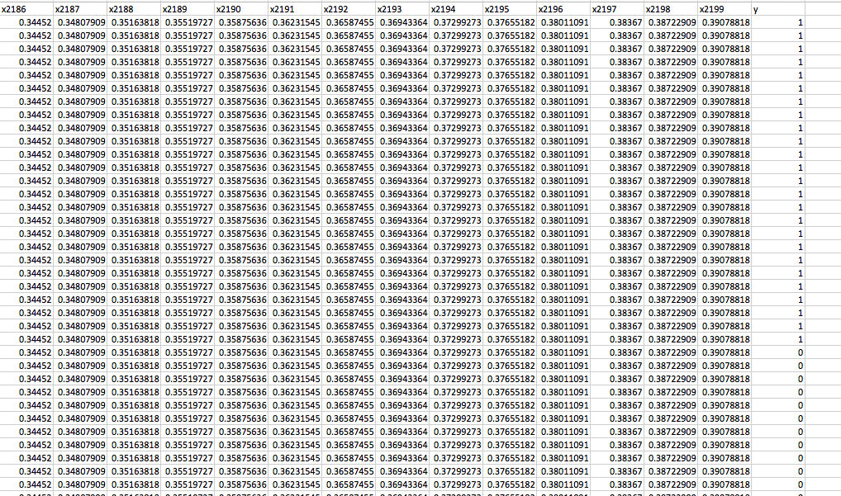

As can be seen there are a lot of inputs, 2199 to be exact. This should be considered in the network architecture. Also this is a binary classification problem so only one output is required.

Huang 2003 Learning Capability and Storage Capacity suggests :

In this paper, we have rigorously proved in a constructive way that TLFNs with L1=SQRT((m+2)N)+2SQRT(N/(m+2)) neurons and L2=mSQRT(N/(m+2)) neurons in the first and second hidden layers, respectively, can learn N distinct samples (**x**i,**t**i) with any arbitrarily small error, where **x**i∈**R**n and **t**i∈**R**m. On the other hand, given a TLFN with Q hidden neurons, we know that it can learn *at least* Q2/4(m+2) distinct samples (**x**i,**t**i) with any desired precision.

M = output and N = inputs

So L1 = sqrt(3*2199)+2*sqrt(2199/3) = 135

L2 = sqrt(2199/3) = 27

So, I will begin with this. Another option could be adding a convolutional layer.

Using a 75-instance training set with a stationary vehicle the network has 100% accuracy and very low loss. I want to test this on real data of a much larger set to get a better idea of whether it is working or not (Overfitting). Then I can write code for the full process of data gathering and classification and make a Neural Network for each fault.

Report: Discuss NN choices out of possibilities.

Training a model that works on all unknowns? How to test

Fixing Weights on interesting areas

Lowering the layer numbers

## Further Goals

* Neural Network
  + Train on real data
  + Train for faults
  + Exporting data – saving and loading models and using weights in other applications
  + Averaging?
  + Convolution of Data
* Collect Further Training Data
* Ack for the End Time

### Train with Real Data